**VALLEY VIEW UNIVERSITY**

**DEPARTMENT OF COMPUTER SCIENCE**



March 19, 2020

**VALLEY VIEW UNIVERSITY**

**FACULTY OF SCIENCE**

**DEPARTMENT OF COMPUTER SCIENCE**

**A RESEARCH PROJECT SUBMITTED IN PARTIAL FULFILLMENT OF**

**THE REQUIREMENTS FOR THE BACHELOR OF SCIENCE (BSC.) IN**

**COMPUTER SCIENCE DEGREE**

**TOPIC:**

**ELECTRONIC DOCUMENT MANAGEMENT SYSTEMS**

**CASE STUDY (GHANA MILITARY ACADEMY)**

**BY:**

**STEPHEN MENSAH-SAM**

**ID:**

**219KFCS01070132**

**SUPERVISOR:**

**MR. SAMUEL TAWIAH**

**DATE:**

**MAY 2020**

# Acknowledgement

Let me take this opportunity to thank all persons who in one way or the other contributed towards the success of this research project.

First of all, I wish to thank the almighty God for his sufficient grace and mercies for the gift of life and for having granted me good health in my whole life and throughout my study.

Secondly, I would like to thank my supervisors Mr. Samuel Tawiah for his support, guidance, and encouragement throughout until the completion of my research project.

Thirdly, to all staff in The Ghana Military Academy who accepted to provide data that was used in my research.

Lastly, I wish to take this opportunity to thank those people who directly or indirectly contributed to the success of this project.

# Declaration

This is to declare that, the research work underlying this senior research project has been carried out by the under mentioned student under the supervisor. Both student and the supervisor certify that the work documented in this thesis is the output of the research conducted by the student as part of his final year project work in partial fulfillment of the requirement of the Bachelor of Science in Computer Science degree.

**STUDENT:**  **SUPERVISOR:**

STEPHEN MENSAH-SAM MR. SAMUEL TAWIAH

------------------------ ----------------------

DATE: DATE:

# Abstract

This research aimed at investigating the implementation of Electronic Document Management System at The Ghana Military Academy. The specific objectives were: To prevent lost document and find documents quickly. To save storage space manage document easily · To eliminate the need for filing cabinets (including storage rooms or buildings) that makes documents centrally available. Again, make the information safe (computer ‘data’ can be readily duplicated.

A case study research method was adopted to ensure greater reliability of data. Both qualitative and quantitative approaches were used to analyze, present and interpret data. To respond to the above objectives, data was collected using observation, questionnaires, documentary reviews, and interviews. The study focused at the Ghana Military Academy in which 2 staff were selected to respond to research administered interviews. Major finding of the study is that, Ghana Military Academy still uses the manual document management system despite the fact that an EDMS was installed, Ghana Military Academy has a document management policy that is not known to everyone; there are inadequate documentation, inadequate finances and resistance to change by staff thus affecting the implementation of the EDMS. Recommendations include: creating awareness of the document management policy to staff; investing on training staff on EDMS and change management; adopting the methodology framework to implement the EDMS in Ghana Military Academy.

# Table of Contents

Acknowledgement ii

Declaration iii

Abstract iv

Table of Contents 1

Table of Figures 3

Chapter 1 4

1.0 Introduction 4

Subject and Field of Study 5

1.1.1 Problem Statement 5

1.2 Objectives of the Study 7

1.2.1 General Objectives 7

1.2.2 Specific Objectives 8

1.3 Background to the study 8

1.4 Scope of Study 10

1.5 Significance of the study 10

1.6 Methodology 10

Research questions 10

1.6.1 Assumptions of the study 11

Chapter 2 13

Literature Review 13

2.0 Introduction 13

2.1.0 Meaning of Document 13

2.1.1 Document Management 15

2.1.2 Document Management and Information Management 17

Figure 2.1: The Hierarchy of Information Management 24

Source: Information Solutions Group (2000) 24

2.1.3 Life-Cycle of Document 24

2.2.0 Document Management Practices 27

2.2.1 Centralized and Decentralized/Departmental Filing 32

2.2.2 Forms of Document Management 33

2.2.2.1 Manual or Paper-based Document Management 33

2.2.2.2 Importance of Manual or Paper-based Document Management 34

2.2.2.3 Problems associated with Manual Document Management 35

2.2.3.0 Electronic Document Management 35

2.2.3.1 Importance of Electronic Document Management 37

2.2.3.2 The Challenges Associated with Electronic Document Management 38

2.2.4.0 Comparison of Electronic Document Management with Manual Document 39

2.3.0 The Benefits of Proper Document Management 42

2.4.0 Challenges Associated with Document Management 49

2.5.0 Conclusion 52

2.6.0 Conceptual Framework 54

Figure 2.2. Conceptual framework explaining document management practices in organizations. 54

Chapter 3 55

3. Crystallization of the Problem 55

i. Background/History 55

i. Process of the Existing system 55

iii.a. The Strength/Advantages of the system they use 56

iii.b. The weakness/Disadvantages of the system they use 56

Chapter 4 57

4. Analysis of the Proposed System 57

4.1 Overview of the Proposed System. 57

- Functional Requirements 57

- Non-Functional Requirements 58

4.2 Major Features/Components of the Proposed System. 60

4.3 Benefits/Advantages of the proposed system 61

4.4 System Context Diagram of the proposed system 64

# Table of Figures

Figure 1 System Context Diagram 1 64

Figure 2 System Context Diagram 65

# Chapter 1

## 1.0 Introduction

This thesis gives an overview of how the electronic document management system (EDMS) can be used to capture, store, archive and retrieve printed documents (and documents in electronic format) through a centralized customizable interface which has the capability to automate common processes.

A document is any readable material that is used for business processes. Documents can be in multiple formats – printed pages, word processing documents, spread sheet, fax, presentation documents, photos, internet pages, medical images, AutoCAD drawings etc. We are handling more of electronic documents these days and then converting it to paper-based documents, where required, by printing them. What if the entire process can be handled electronically without having to use papers at all? Then comes the storage and retrieval of such printed documents, it always happens that the most important file we are looking for is always not available like a copy of a purchase order invoice etc. So if all electronic documents are stored electronically, it would be much easier to locate an important document that we may want to reference at that instant. And then comes the electronic documents like word documents, power point files, auto cad files, emails etc. If the electronic documents are also indexed by a central document management system, they could also be searched using some keywords in their contents, tags like date of creation, person who saved etc.

In this study, a document management system developed for the Ghana Military Academy is discussed.

## Subject and Field of Study

The aim of the study was to investigate the success of the implementation of electronic document management system in the Ghana Military Academy and suggest recommendations for improvement where necessary.

## 1.1.1 Problem Statement

In 2011, the Ghana Statistical Service estimated that a greater chunk of the 23% budget expenditure on education went into the tertiary education. However, in spite of all these financial strides made by the government, tertiary educational institutions like the universities are not only facing complex managerial problems (Atulomah, 2011). Addo (2010) was of the view that the problems in most universities in Ghana tend to be inadequacy of funds, student population explosion and a lack of an efficient and effective document management systems. The woes of document management systems of government institutions are not isolated to Ghana alone. It has become a recurrent issue for document to be irretrievable when required especially in government institutions of most developing countries (Fabunmi, 2004). The difficulty of this problem is better appreciated by those who bear the brunt especially government and administrators who require institution document to facilitate accurate and timely decisions. In such a situation management find it difficult to retrieve the information they need to formulate, implement and monitor policy and to manage key personnel and financial resources.

In Ghana, the problem mostly arises where government institution and others have to allocate large office space to keep management files manually every year. (Bailey et al 2011). Again, educational institutions especially the universities must keep large volume of students’ examination papers and results for at least five years before they can be disposed of. It is however becoming clearer that it is more pronounced in the university system because accurate, reliable and trustworthy document that fulfill evidential requirements are being created but not properly managed (Longe, 2001).

Based on the problems stated above the need for all public and private organization to keep proper document cannot be overemphasized. Therefore, out of convenience purposes the research has been chosen.

## 1.2 Objectives of the Study

(i) To establish whether there is a policy framework for the implementation of electronic document management system in Ghana Military Academy.

(ii) To find out whether user needs were met by the electronic document management system.

(iii) To find out the opportunities that exists by using electronic document management system in Ghana Military Academy.

(iv) To identify the challenges facing implementation of electronic document management system in Ghana Military Academy.

(v) To provide recommendations and a framework to enhance proper implementation of electronic document management system in Ghana Military Academy.

## 1.2.1 General Objectives

(i) Provide better service to the public by improving the quality and quantity of information available, by providing easier access to the information.

(ii) Increase staff productivity and efficiency by reducing paper handling.

(iii)Reduce physical storage and Enhance security.

Improve Regulatory Compliance/Document Management and Retention.

(iv) Increase collaboration and Improve backup and recovery of information.

## 1.2.2 Specific Objectives

1. To prevent lost document and find documents quickly ·
2. To save storage space manage document easily ·

(iii)To eliminate the need for filing cabinets (including storage rooms or buildings) that makes documents centrally available. Again make the information safe (computer ‘data’ can be readily duplicated.

## 1.3 Background to the study

In the late 1980s, a number of vendors began to develop software systems to manage paper-based documents. These systems dealt with [paper documents](https://en.wikipedia.org/w/index.php?title=Paper_document&action=edit&redlink=1), which included not only printed and published documents, but also [photographs](https://en.wikipedia.org/wiki/Photograph), prints, etc.

Later developers began to write a second type of system which could manage documents, that is, all those documents, or files, created on computers, and often stored on users' local [file-systems](https://en.wikipedia.org/wiki/File-system). The earliest electronic document management (EDM) systems managed either proprietary file types, or a limited number of [file formats](https://en.wikipedia.org/wiki/File_format). Many of these systems later became known as [document imaging](https://en.wikipedia.org/wiki/Document_imaging) systems, because they focused on the capture, storage, indexing and retrieval of [image file formats](https://en.wikipedia.org/wiki/Image_file_formats). Electronic management systems evolved to a point where systems could manage any type of file format that could be stored on the network. These systems enabled an organization to capture faxes and forms, to save copies of the documents as images, and to store the image files in the [repository](https://en.wikipedia.org/wiki/Information_repository) for security and quick retrieval (retrieval made possible because the system handled the extraction of the text from the document in the process of capture, and the text-indexer function provided [text-retrieval](https://en.wikipedia.org/wiki/Text_retrieval) capabilities).

While many electronic management systems store documents in their native file format (Microsoft Word or Excel, PDF), some web-based document management systems are beginning to store content in the form of [html](https://en.wikipedia.org/wiki/Html). These policy management systems require content to be imported into the system. However, once content is imported, the software acts like a search engine so users can find what they are looking for faster. The html format allows for better application of search capabilities such as full-text searching and stemming.

## 1.4 Scope of Study

A document management system makes managing, editing, creating and organizing documents easy. You do not have to look into a lot of files and folders as in the case of paper documents.

The study area was limited to the Ghana Military Academy headquarters staff.

## 1.5 Significance of the study

The study findings would assist Ghana Military Academy to strengthen electronic implementation strategies by emphasizing more specifically on management of electronic document as a vital component in scaling up efficiency and effectiveness in service delivery in Organizations.

The study was limited by scarcity of literature because few studies have been done on electronic document management systems in Ghana.

## 1.6 Methodology

## Research questions

(i) Does Ghana Military Academy has a policy for EDMS?

(ii) Were the user needs (Ghana Military Academy Staff) met by the EDMS?

(iii)What are the opportunities of using EDMS in Ghana Military Academy?

(iv) What are the challenges facing implementation of EDMS in Ghana Military Academy?

(v) What recommendations would be required to enhance proper implementation of EDMS in Ghana Military Academy?

## 1.6.1 Assumptions of the study

The study was based on the following assumptions:

Although electronic document management is a critical aspect in reduction of costs incurred at Ghana Military Academy, the manual system is still in existence.

All staff in Ghana Military Academy understands electronic document management system commonly referred to as “EDMS”.

The software development process model is Spiral. The reason is that Spiral model is a combination of both, iterative model and waterfall model. This model considers risk, which often goes un-noticed by most other models. The model starts with determining objectives and constraints of the software at the start of one iteration. Next phase is of prototyping the software. This includes risk analysis. Then one standard SDLC model is used to build the software. In the fourth phase of the plan of next iteration is prepared.

1.7 Summary

This chapter has discussed the introduction and background information of the study, the background information of the Electronic document management system, the statement of the problem, the objectives of the study, the research questions, and the significance of the study, the scope and limitation of the study.

# Chapter 2

## Literature Review

## 2.0 Introduction

This chapter reviews literature related to this study. It is organized under the following; the meaning of document and document management, document management practices, benefits derived from document management and challenges associated with document management.

A literature review is both the process and the product.

A literature review is a descriptive, analytic summary of the existing material relating to a particular topic or area of study.

The literature review process involves a systematic examination of prior scholarly works.

## 2.1.0 Meaning of Document

In order to define document management, the concept of “record” needs to be fully explored. A record is defined either in terms of the physical tangible format in which it appears, or in terms of the information it contains. It must be noted that document differ in format or size, and have different contents. The term record comes from the Latin word “recordari”, which means to recall, or to remember, or bring back to mind, and this is exactly what document do (Pember and Cowan, 2010). Cox (2001) also explained document as an extension of human memory, purposefully created to record information, document transactions, communicate thoughts, substantiate claims, advance explanations, offer justifications and provide lasting evidence events.

Document can be defined as "documented information, in any form, created or received and maintained by an organization or person in the transaction of business or conduct of affairs and kept as evidence of such activity". Again, Langemo (1995) defines a record as the memory of the organization, the raw material for decision making and the basis for legal defensibility (GMA Document Management Policy Framework, 2000). Kallus (1991) further defines a record as written or oral evidence that has been collected and kept for use in making decisions. The most common document (such as forms, correspondence, reports and books) are written, printed or typed on paper. Oral document captures the human voice on tape, and are stored on cassettes or on other magnetic media. In support of Kallus’s (1991) definition, Quible (1996) further defines document as informational documents such as forms, letters, memoranda, reports and manuals used to carry out various functions.

In a nutshell, the concept “record” can be defined as the information captured for re-use at a later stage as evidence of an activity or action undertaken, and a basis on which future decisions are made. Document is important and it is difficult to imagine life without them, particularly in the running of an organization (Penn et al., 1994).

## 2.1.1 Document Management

Institutions create document to support the activities that they carry out. However, if these documents are not manage properly, they will not provide the necessary support and information might be lost causing problems for the institution, To provide an efficient and effective administration that ensures that the business runs as smoothly as possible, there should be proper management of document. Document management is the application of systematic and scientific controls to recorded information required in the operation of an organization’s business (Zawiyah and Robert, 1999).

Again, International Organization for Standardization (ISO) 15489 (2001) explained document management as the field of management responsible for the efficient and systematic control of the creation, receipt, maintenance, use and disposition of document, including the processes for capturing and maintain evidence of an information about business activities and transactions in the form of document. Document management is also the discipline of applying well-established techniques and procedures to the control of those sources of information, which arises internally within an organization as a result of its own activities (Newton, 1986).

Unuigbe (1990) saw document management as the quality, quantity, and cost of document and encompassing the procedures, systems, operations, space, equipment and staff required for managing the document. Asiwaju (1985) recognized that document management is a dynamic science of handling recorded information for immediate and future use efficiently and economically. Furthermore, Pali (2009) pointed out that document management is the systematic control of all document, either in media format or printed materials from their creation until its final disposition; including the development and application of standards to the creation, use, storage, retrieval, disposal and archival preservation of recorded information. In summary, an effective document management program will ensure that document are available for use when needed, that privacy and confidentiality are maintained, that redundant document are destroyed and that document ultimately contribute towards sustaining service delivery.

## 2.1.2 Document Management and Information Management

Document management and information management are two terms often used interchangeably (Atolumah, 2011). Some authors have gone at lengths to draw similarities between the two, while others insist that there are differences. For example, document management over the years has increasingly been referred to as document an information management. The merger of these two terms shows how slight a difference exists between them. Information management entails the management of all the information in an organization as well as the management of the people, hardware, software and systems that produce the information.

Document management is portrayed as means of good information management, improving and enlightening the management of organizations (Yusof and Chell, 1999). Information management is a broader concept within which document management falls. In other words, the main purpose of document management is to manage and control the flow of document with the necessary information within a particular organization.

According to Robek et al., (1987) document management is a systematic control of the recorded information that an organization needs to conduct business. Ricks et al., (1992) stated that document management is a function of providing systematic control of document from creation, or receipt, through their processing, distribution, organization, storage and retrieval to their ultimate disposal.

Penn et al., (1994) also saw document management as the management of any information captured in reproducible form that is required for conducting business. Mazikana (1990) emphasizes that document management is concerned with the generation, receipt, processing, storage, distribution, use and disposal of document. It encompasses a wide variety of activities and sub-disciplines such as the management of mail, correspondence, reports, copies, forms and directives. Document management is further viewed by Place and Hyssop (1982) as a process of controlling organizational information from the creation through its final disposition. Ricks And Gow (1988) also defines document management as the systematic control of document from creation of document to final disposal. Furthermore, Langemo (1999) pointed out document management as the professional management of information in the physical form of document from the time document are received or created through their processing, distribution and placement in a storage and retrieval system until either eventual elimination or identification for permanent retention in the archives.

The most effective information management system manages all information, regardless of medium and format. For example, human resource information management system, accounting information management system, decisions and executing support information systems. Information management simply entails the process of planning, controlling, and using the information resources of an organization in support of its business.

## Figure 2.1: The Hierarchy of Information Management

Information management

Document management

Archives management

Publication management

Database management

## Source: Information Solutions Group (2000)

Figure 2.1 above shows that information management is a broader concept within which document management falls. In other words, the main purpose of document management is to manage and control the flow of document with the necessary information within a particular organization.

## 2.1.3 Life-Cycle of Document

The life of a record goes through phases starting from when it is created or received by the institution, through to its usage, maintenance and finally disposal. The life-cycle of a record is a basis on which a document management system is made, as the system stipulates the procedures and processes that organizations need to follow at each phase of the record’s life-cycle. Efficient life-cycle management of document is a key concept in document management. If institutional bodies do not control document through the earlier stages of their life-cycle, document that have low administrative value are kept too long and those of archival value cannot be identified and safeguarded (National Archives and Document Service of South Africa, 2007).

All document has a life cycle from creation/receipt (birth), through into the period of active currency (youth), then into middle-aged closed files that are still referred to occasionally, and finally either confidential disposal or archival preservation (Document Management Policy Framework, 2000).

Again, one of the core concepts in document management is that of the record’s life cycle. The concept of a life cycle is at the core of most document management programs. The activities of document management programs are developed upon this concept, which has several phases that explain the stages or status of document thus from creation through use and maintenance to ultimate disposal (Erlandsson, 1997). It continues as document are stored for an additional period of infrequent or dormant use in off-site document canters, and ends when their operational use ends entirely, or when they are ‘selected’ as archrivals valuable and transferred to an archive, or declared non-archival and destroyed. The life-cycle of document reflects the opinion that all document, irrespective of form and purpose, pass through certain well-defined phases (Newton, 1989). Each phase requires special techniques for effective control. On the other hand, Gill (1993), emphasizes that the record’s life cycle means a movement of document in logical steps from the creation, through its use, storage, and retention in active files, to its transfer to inactive files, storage, and finally disposal.

Often, the division and the meaning of the life-cycle stage depend on the individual organization. In some institutions, the disposition stage would mean ultimate destruction whereas in another it means sending those documents to the archive for research and posterity (Zawiyah and Robert, 2000). Brooks (1996) discusses the life cycle concept in relation to the appraisal process. He argues that the selection of document for disposal or preservation must be accompanied by a thorough understanding of their value. Brooks (1996) ascertains that before a record is created, the professional background and level of knowledge of the creators plays a significant role. Only document with enduring value are permitted to undergo the complete life cycle process. Finally, Porter-Roth (2006) pointed out the following as the basic stages in a document life cycle; capturing, managing, storing, delivery and disposition stages.

## 2.2.0 Document Management Practices

The past twenty years has revolutionized the way in which information is generated and stored (Beastall, 1998). The service provided by document management is vital to any institution, and to every information-using employee in it. Its primary function is to facilitate the free flow of document through an institution, to ensure that information is rapidly available where and when it is needed. To carry out this function needs an efficient, effective document management programme. By helping the users to do their jobs better and more easily, the document manager serves the institution. Given that an organization’s documents are unique to it, they need to be managed explicitly, just as the organization would manage its other resources (people, money and estate).

Document management systems and procedures should facilitate compliance with university policies. Specific business functions and activities within universities may be subject to specific legislation or to professional best practice or relevant ethical guidelines.

Again, heads of institutions, schools, other units and business functions within the university have overall responsibility for the management of document generated by their activities thus ensuring that document controlled within their units are managed in a way which meet aims of the University's Document Management policies. The Registrar has a particular responsibility in ensuring that the University corporately meets its legal responsibilities, and internal and external governance and accountability requirement. Day-to-day responsibility will be delegated to a Document Manager, who will report to the Registrar. The Document Manager will have a coordinating and enabling role and will advise on policy and best practice. The key document management practices in the University document management policy framework are document creation and capture, document survey/audit, document analysis/retention schedule, disposal of document, document protection and security and provision of appropriate training for relevant staff (UEW Document Management Policy Framework, 2000).

Kanzi (2010) pointed out that for a sound document management practices to take place, heads of institutions should designate or appoint a staff member (Document Manager) at senior management level to whom they can delegate the responsibility of ensuring that sound document management practices are implemented and maintained. He added that document managers should develop and implement document management policies, which are endorsed by the heads of the institutions and their top management teams. Adherence to these should be continuously monitored and be reviewed on an annual basis. Furthermore, he stated that there should be document management procedures to serve as a guide to employees, document classification system to facilitate efficient retrieval and disposal of document, and training of document managers and document office staff to equip them with the necessary skills to carry out their functions properly.

Utulu (2001) also mentioned that if any information was to be lost or misplaced, it could cause a range of problems some of which might affect the future of students needing essential information from their document. According to Afolabi (1999), Document Management and Archives staff should be responsible for providing an appropriate record management training programme to the University staff. Again, he added that document should not be taken from the University without the permission of the Document Manager/Archivist or an appropriate Office Manager. Scholars of document management theory and practice agree that, in principle, organizations should create and capture document for every activity that involves more than one party and that they should identify and record every process that generates document (Bearman 1994; Reed 1997; Shepherd and Yeo 2003). Therefore, document must be authentic, complete and usable. For example, even Information Communication Technology (ICT) systems must be able to generate or capture the ‘metadata’ that record the contents, contexts and structures of document within the business processes that produce them (IRMT, 2008).

In addition, Shepherd and Yeo (2003), when assessing the need to create and capture document, suggested that it is essential to consider the requirements of the organizations or particular business units that need document to provide evidence and information for operational use, the requirements of the organizations, particular business units or external stakeholders that need evidence to ensure accountability, the cost of creating, capturing and maintaining the document that organizations require and the risk to them if they do not have these document.

International Organization for Standardization (ISO) 15489 (2001) is of the view that a policy for creating document is also necessary. It should stipulate the requirements for capturing, registering, classifying, retaining, storing, tracking, accessing and disposing of document. Organizations create and keep document so that designated users, mostly from within the organizations and occasionally from outside, can use them when they need to. Any document management system that captures document must have systems that allow users to use the document thoroughly (Shepherd and Yeo 2003). Therefore, institutions create document for a purpose. The timely and accurate retrieval of document depends largely on how well organized and classified the document are. As a result, document classification systems should reflect the business activities of the organizations. Organizations need to determine the degree of classification control they require for their business purposes (ISO 15489-2001). Shepherd and Yeo (2003) also pointed out that classification schemes are based on an analysis of functions processes and activities and document the structure of a document management system and the relationship between document and the activities that generate them. Again, they emphasized that it is necessary to use appraisal techniques to support decisions about retention, that is ‘which document can be destroyed at an early stage, and which merit longer-term or indefinite retention’. Other researchers and authorities emphasize that any effective document management programme requires classification (Kemoni 2007; Reed 2005). Vocabulary control tools usually support classification systems. They give institution-specific definitions and explain the usage of terms.

Institutions should establish ongoing programmes for training in managing document. Institutions can design or set up this training together with external bodies. They cannot retain files, irrespective of their format (paper or digital), indefinitely. The reason for this is the cost of storage and maintenance as well as slower and difficult access because of the high volumes.

Document systems should be able to facilitate and implement decisions about retaining or disposing of document. Therefore, the effective management of document requires that there are procedures for the timely disposal of document that institutions no longer need to support current day-to-day activities or those that they do not need to retain for legacy purposes (ISO 15489, 2001).

## 2.2.1 Centralized and Decentralized/Departmental Filing

Filing may be organized centrally or departmentally. Some organizations choose the centralized filing system, while others prefer de-centralized/departmental filing. Others also find both systems to be good. Centralized filing is whereby all the files of an Institution are kept and controlled in one room instead of allowing each department to file its own document. In many large organizations, a separate department (central filing department) is created to take care of its filing trained personnel called document managers who are in-charge of all filing and so filing is done more efficiently. This makes it possible for effective supervision to be exercised over files including the movement and placement of correspondence on files.

Decentralized or departmental filing is a system by which each department or section of an organization keeps and maintains its own system of filing which best suits it (Arora, 2006).

## 2.2.2 Forms of Document Management

Correspondence is normally conducted manually or electronically through electronic mail or intranet. Documents such as policies, procedures, contracts, regulations, minutes, circulars are often available for administrative staff to update or familiarize themselves with the normal operation of their institutions. Ignorance of such documents may affect the competitive performance of an institution. This implies that information in the form of document is used by institutions through staff as a strategic weapon to gain a competitive advantage for the organization that creates, receives and uses them effectively (Mrwebi,2000).

## 2.2.2.1 Manual or Paper-based Document Management

Paper based document are any document that have been written or printed on paper. They can be items such as hand written notes, correspondence, printed reports, procedures or maps. Universities are responsible for creating full and accurate document of all their activities and decisions in accordance with standard record management requirements. When a record is created or received, it is up to the user to ensure that it is filed and documented correctly to allow for easy tracking and further use by the organization Azman (2009).

2.2.2.2 Importance of Manual or Paper-based Document Management Paper as a medium has been important to our species at least since the time of ancient Egypt, when the papyrus roll was developed and initially used for religious and administrative document management purposes and later for storing and disseminating (in a restricted way) knowledge on mathematics, surgery, and engineering (Martin, 1992). Even the advent of the personal computer, and predictions of the paperless office, have not interfered with our fondness for paper. In fact, with each passing decade of the personal computer revolution, paper consumption has increased (Sellen and Harper,2002).

Paper plays an important role in organizational life. Paper documents such as schedules and flow charts provide a gathering place for workers to view information and be seen viewing information. Sellen and Harper (2002), showed that large paper documents became the foci of organizational life.

Again, Whittaker and Schwartz (1995), found that even the computer professionals who studied, viewed their large paper schedules as “more real” than its electronic counterpart. The paper schedule, for example, was public, and therefore not only motivated work but also helped people be aware of what others were doing. Moreover, printed artefacts seem to serve as centers for societal interaction and memory. This was also found to be true in the health care arena (Nygren and Henriksson 1992).

## 2.2.2.3 Problems associated with Manual Document Management

Gregg (2013) came out with two challenges faced by paper-based document management. Accessibility through hardcopy files is limited because paper-based information can only exist in a single location at a time. He added that with one copy of a document in existence, only one person can access that information at any given time. This serial approach to information management does not play well in today’s “I need it now” business environment. This is especially the case since most organizations are decentralized and geographically dispersed. When there is only one version of information, managing the hardcopy document involved becomes a physical challenge

## 2.2.3.0 Electronic Document Management

Document management has evolved from a paper-based function responsible for the storage of an organization’s miscellaneous documents, to one concerned with the management of specified internal document, in a multitude of media, from creation to disposal, through their active use as sources of information and hence of ultimate review against retention schedules, for their eventual destruction (De Wet and Du Toit, 2000).

The introduction of computers therefore assists in achieving and adding value to the conduct of business transactions (Johari, 2001). Electronic document management is very important to every institution because document is one of the University's most valuable assets. Document support decision making, demonstrate compliance, document the history of the University, and perhaps most importantly, enable the institution to do their jobs. Document need to be properly managed in order to maximize their value and minimize their cost. By implementing good document management practices, the institution can control, avoid and even decrease the costs associated with maintaining the document and improve the efficiency of the business operations (Hebert, 1998).

In this modernized world of computers, it makes sense to manage document electronically, with Universities spreading out or having different locations, yet totally being tied together with the internet. This just makes plain sense to have an electronic document management system. In fact, it is so important that many institutions absolutely require it as it has become the standard in business, rather than the exception.

## 2.2.3.1 Importance of Electronic Document Management

Institutions are under increasing pressure to become more efficient while at the same time maintaining or improving the quality of service. Electronic document with its potential plays an important role in supporting efficiency, accuracy and accessibility of information. Sing (2002) pointed out that there is a direct relationship between investment in electronic document and productivity improvements in the office and these include; better customer service, greater product/service variety, shorter response time, enhanced product/service quality and better customization of products and services.

The implementation of sound record management practices for electronic document can result in a number of benefits for government. One of the most important benefits is to ensure a creation and management of accurate and reliable electronic document. This allows organizations to fulfill legal mandates regarding the protection of their document. Other benefits include; ensuring the legal acceptability of the organization’s electronic document, reducing the burden of paper document management, identifying appropriate means for the movement of document to successive generations of technology and systems, and finally improve citizen access to public information (Mashburn,2001).

## 2.2.3.2 The Challenges Associated with Electronic Document Management

While information technologies have brought many benefits to organizations, they have also introduced a number of challenges and difficulties. The challenges posed by electronic document, particularly in the public sector, have been highlighted by Mnjama and Wamukoya (2007).These challenges include absence of organizational plans for managing electronic document, low awareness of the role of document management in support of organizational efficiency and accountability, lack of stewardship and coordination in handling paper as well as electronic document, absence of legislation, absence of policies and procedures to guide the management of both paper and electronic document, absence of core competencies in document and archives management, absence of budgets dedicated for document management, poor security and confidentiality controls, lack of document retention and disposal policies, absence of migration strategies for electronic document.

According to Hebert (1998), electronic document increased efficiency and productivity using the hospital environment with the interactions between health workers and patients and for shorter duration. Thus, it does not 'free up time' for workers to interact with other co-workers physically. Other effects include reduction in job satisfaction as more time is spent on the computer.

## 2.2.4.0 Comparison of Electronic Document Management with Manual Document

Both electronic and manual document management come with varied benefits to businesses and organizations in respect to data storage. However, current literature suggests that electronic document management have proven to be effective as compared to the manual. For instance, Iziomo (2014) identified that electronic document management gives unlimited storage space as compared to conventional method of office cataloging that involves categorizing several ink printed papers in a cabinet to allow for retrieval when needed.

Data retrieval is one area where computers clearly excel. Finding a particular piece of information is infinitely easier with a modern computer system than it is with reams of paper. Solving a particular problem may, in fact, take longer with Paper Patient Document (PPRs), despite the fact that reading from paper is generally easier. But finding a particular piece of information presupposes one knows what one is looking for, which is not always the case. Gen (2008) stated that paper-based systems have improved communication, ability to have remote access of patient information, and improved revenues. He perceived that electronic health document (EHR) would provide improved communication between practitioners and patients. For instance, paper-based system improved communication between inpatient and ambulatory practices; information retrieval between these two is currently difficult and time-consuming.

According to Gen (2008), half of the paper-based system leaders were especially interested in having remote access to patient information. On the other hand, electronic health record would enable physicians to provide more knowledgeable advice during off- site/off-regular hours. He mentioned that there is an immense expectation of the EHR to improve overall practice efficiency and revenue. Also, enhanced efficiency would be created through decreasing time-consuming activities such as chart retrieval. Finally, he believed that the EHR would boost revenues by improving billing and collection by capturing the true work load.

O’Hara and Sellen (1997) studied the differences in process between reading paper documents versus electronic documents. Their experiments showed that there was a number of advantages to paper that must be addressed by the design of digital systems. Among the advantages that paper offers is the way it supports annotation while at the same time permitting quick and easy navigation, which in turn permits the user to develop a sense of overall structure.

Furthermore, they learned that improvements in navigation and control of spatial layout of individual and multiple documents must also be supported in electronic documents. In line with this, Ovsiannikov et al., (1999) showed that digital systems can support annotation and that there can be a number of advantages to electronic annotation technology if properly implemented. For example, annotations can be stored in an annotation database and make retrieval and document summaries much easier, they can be linked permitting hypertext navigation, they can be easily shared. All this is not to say that paper is in and of itself superior to electronic media. Golovchinsky (1997) pointed out that users prefer interfaces that provide for multiple navigation options. Paper provides a very transparent interface, given its lack of modalities. It facilitates active reading and various modes of note taking (Niinimaki et al., 1989).

Schilit et al., (1998) attempted to duplicate this functionality of paper document with the XLibris project. XLibris used the paper document metaphor to provide computers with some of the affordances of paper. Xlibris, a tablet computer, has a flat panel display and permits pen input. Unlike paper, however, it permits multiple navigation mechanisms, including “turning pages”, document view showing all pages of a document, and a history view that permits backtracking through a reading session.

According to Marchionini (1995), browsing is different from navigating and can be associated either with the goal of the activity or with the method used to achieve the goal. Paper facilitates browsing, even in a medical environment. It is easy to hold several pages next to one another for comparison.

## 2.3.0 The Benefits of Proper Document Management

A number of institutional benefits will accrue to any University when proper document is kept. These benefits include better use of physical and server space, save staff time, improved control of valuable information resources, compliance with standards and reduction in its operational costs (UEW Document Management Policy Framework, 2000).

According to Sanderson and Ward (2003), the importance of document management is increasingly being recognized in organizations. It is therefore the responsibility of document managers to ensure that they gain the attention of decision-makers in their organizations. Gaining recognition is all about convincing management of the role of document management as enabling unit in an organization.

Administrative staff required information in order to carry out their official duties and responsibilities efficiently and effectively in a transparent manner. Document represent major sources of information and are almost the only reliable and legally verifiable source of data that can serve as evidence of decisions, actions and transactions in an organization (Wamukoya, 2000). Again, Northwest Territories (2003) suggest that the role of document management is to ensure that members of staff involved in different operations have the information they need, when necessary. Also, De Wet and Du Toit (2000) stated that the service provided by document management is of vital importance to both employees (end users) and organizational success. The primary function of document management is to facilitate the free flow of document throughout the entire institution. Most importantly, it remains the function of document management to ensure that an organization’s document is safe for future reference.

According to Palmer (2000), the role of a document management system is that it acts as a control system that reinforces other control systems such as internal and external auditing. The document themselves can serve to detect fraud and recover the loss. Since corruption creates an environment that allows opportunities to commit fraud, document can provide a trail for investigators to track the root of corruption. However, for document to be useful in this capacity, they must be accessible. In Hare and McLeod (1979) views, organizations keep document for the following reasons; information retrieval, evidence of organization’s activities, compliance with regulations. In support of Hare and McLeod, Cowling (2003), further identified four main reasons motivating organizations to preserve document permanently as: administrative value, financial value, legal value and information value.

In summary, it may be appropriate to indicate that document exist in order to remind institutions of their previous activities. Hounsome (2001) noted that while document management may seem boring to many, it is hard to under-estimate in the role played by document management in organizations. The document is the corporate memory of the organization, evidence of what was done and why it was done. They provide information for different institutional purposes, such as decision making, financial accountability, performance measurement, strategic planning and research.

Without divorcing themselves from the above scholars, Sanderson and Ward (2003) further explored the role of document management in an organization as avoiding the cost of litigation or failure to comply with regulatory bodies, preventing the loss of intellectual property or loss of corporate learning/corporate memory, preventing loss of information from disasters or theft and ensuring business continuity, maximizing the efficiency of operation and usage of information, responding in a timely and effective way to requirements of customers, protecting executives and their organizations from loss of reputation and credibility with the general public and customers by demonstrating good practice and providing accountability for their actions.

Thurston (2005) argues that dysfunctional document management undermines legal and judicial reform. Decisions are made without full information about cases, and the absence of systematic record management and controls leaves scope for corruption or collusion between court officials and lawyers. Court time is wasted, delays are created, and the judiciary’s standing is lowered. The large volume of document passing through a typical court system, their sensitivity, and time pressures on courts makes effective document management essential.

Roper and Millar (1999) opine that, “document are fundamental to the efficient and effective operation of the legal system of a country and perhaps are even more crucial to the administration of law than to any other function of the public sector”. They further stated that, “within the legal context”, document serve several functions; they support legal rights and obligations within the legal system, they provide evidence or proof that a particular activity took place and they contribute to accountability in organizations and in government” (Roper & Millar, 1999). According to Sprehe (2002), document ensure that an organization can; conduct its business in an orderly, efficient, and accountable manner, deliver services consistently and equitably, document its policies, decisions, and outcomes to stakeholders and regulators, meet its legislative and regulatory requirements, including audits, protect itself in litigation, function in a financially and ethically accountable manner, protect corporate interests as well as the rights of employees, clients, and other stakeholders, provide continuity of operations in an emergency or disaster, and maintain its corporate and institutional memory.

Zawiyah and Robert (1999) pointed the following as the benefits of accurate document management; speedy and accurate retrieval of document necessitates systematic filing and storage of document, saves space and prevents duplication of effort with similar document, easier retrieval, better utilization of space, and less frequent loss of documents.

Document management is important because it reduces litigation risks, provides regulatory compliance and protects corporate assets **(**Porter-Roth, 2006). Blake (2014) also said that properly managed document can help reduce operating expenses, enhance customer service and ensure that the company is in compliance with laws and regulations. Without document, no assessment can be made of whether individuals, private and public organizations have actually carried out the actions and transactions that they had to execute, or whether they ensure that these actions and transactions meet the criteria of efficiency, legitimacy or the principles of good governance, and whether they had done things which they were not supposed to do (Thomassen,2001).

Document as important resource for organizations should be harnessed through proper document management practices (Mutula and Wamukoya, 2009). Institutions and individuals create document in the conduct of their current business to support administration, to ensure accountability, and for cultural purposes, to meet the needs of society for collective memory and the preservation of individual and community identity and history (Shepherd, 2010). Document can be used to ensure accountability, to make people and businesses account for their actions and obligations and when there is a need to prove that organizations have complied with legal or regulatory requirements or recognized best practice. Documents enable institutions to meet legal, regulatory, and financial requirements, and to protect their assets and rights.

Proper document management helps to support the expectation of a democratic society for transparency and they protect citizen’s rights. They enable governments to deliver electronically enabled services to citizens (e-government) and facilitate citizen participation through the provision of information and digital interaction (Shepherd,2010). Thus, document have to be managed as a strategic resource so as to facilitate the day to day operations of the institution. For instance, Mnjama (2004) pointed out that there are several reasons why organizations should manage document as a key resource, including: Document themselves are organizational assets because they document organizational activities and are needed for audit trails, especially in establishing who did what, why and when. Document financial activities without proper document, meaningful audits cannot be carried out, fraud cannot be proven, and those responsible for the financial management of the institutions cannot be held accountable for their actions.

Document management serves the cause of history by identifying and preserving important research document. Shepherd (2006) states that document which are managed as part of an appropriate document management programme will help the Organisation to conduct business in an efficient, accountable manner, deliver services consistently, support managerial decision making and transparent policy formulation and ensure continuity in policy execution, management and administration.

In summary, an effective document management programme will ensure that document are available for use when needed, privacy and confidentiality maintained, redundant document destroyed and that document ultimately contribute towards sustaining service delivery.

## 2.4.0 Challenges Associated with Document Management

Brendan (2012) observed the following as the challenges associated with document management; First of all, he noted weak legislative and organizational infrastructures as a major challenge.

Studies by Kemoni and Wamukoya (2000), Iwhiwhu (2005), and Egwunyenga (2009) confirmed that African document keepers lack the basic skills and competences for handling document and archives in the public sector. There is a serious problem of technophobia in most offices in Africa especially among the older employees. Due to inadequate skills in information technology, many traditional librarians, document managers, and archivists are very conservative and have phobia for computers. This may be due to generation gaps between the new and old professionals which led analogue information managers to perceive computers as a threat to their status as experts. Ezeani (2010) in her studies observed that younger librarians are faster in capturing the use of ICTs than the older librarians because “older librarians are finding it difficult to cope with the requirements of the digital age”. Also, Ojedokun (2008) noted that older librarians are “too reluctant to jettison the old practices for new one”. Successful application of information handling technologies in the management of electronic document in developing countries requires an ability to overcome staff and personal resistance.

Brendan (2012) opined that, growing use of information technologies in record management creates a lot of problems in the management of document in both public and private organizations. He added that in Africa and many developing countries governments are looking forward to computerizing their core functions and compelled most African countries to use ICTs in their public services by adopting e-government.

Regrettably these projects fail to succeed because governments neither assess the available information framework suitable for electronic document management, nor consult the document mangers to determine how the process of automation will not affect the role of document managers in providing reliable and authentic evidence.

In Miller’s (2004) view, the conversion from traditional document management activities to electronic environment will not succeed in Africa if the underlying processes are not structured in an efficient and effective fashion. Many African states are jumping into the information technology bandwagon without adequately incorporating good document management strategies.

Lawal (2007) attributed the challenges associated with document management in most organizations to corruption or inadequate finance. According to him, corrupt leaders in Africa do not provide adequate funds, facilities, and infrastructure for proper and efficient electronic record management. Instead, corrupt bureaucrats intentionally distort public policies, public document, decision-making apparatuses, and sometimes go to a length to transfer experienced document managers in a bid to create opportunities for embezzlement. Bribery and corruption contributed to ninety percent (90%) of the underdevelopment of Africa and their ineffective document management institutions. For example, studies have shown that the African Union (AU) in September 2002 estimated that corruption costs African economies more than $148 billion dollars a year.

Otuama (2010) mentioned the following as the problems associated with document management in most organizations; Absence of an archival institution, the problem of oral traditions, inadequate skills and high staff turn-over, inadequate funding, poor housing and equipment, absence of an archival law, high levels of illiteracy, Poor transport and communication network. Ilana (2008) identified lost document and record storage as challenges associated with document management.

According to her, lost document can range from a minor inconvenience for businesses to an enormous hassle that takes months, or even years, to resolve. Thus, if clients request documents from the company on a regular basis and the company is unable to provide them in a timely manner (or at all), the company risks the loss of their business in the future. If important document are needed for a legal matter, such as defending the company against a lawsuit, not supplying the appropriate documents can cost huge sums of money, or even mean the dissolution of the business entirely. On record storage, she stated that, depending upon the type of business for which the company keeps document, as well as how long the company has operated, the company may find itself running out of space.

## 2.5.0 Conclusion

In a world of change, information has become the most dominant resource in the success of organizations and at the same time, organization has to meet increasing regulatory and legal requirements. The management recorded information, irrespective of form or format, is more vital to organizations than ever before (Sanderson & Ward, 2003). In its response to change, record management has moved along with several conceptual frameworks, from archives to information management. Now the discipline has to acquire another framework, derived from information and communication technology.

The problems of record keeping identified generally in the educational system in Ghana include lack of record manual and filing guidelines which lead to loss of vital information and inadequate computer terminals. Others are difficulty in record retrieval and lack of appreciation by management and staff of the need for well-controlled document. However, theory and literature are emphatic as the significant contribution of good record keeping to an organization if it will actualized it objectives in the both short and long term decisions.

## 2.6.0 Conceptual Framework

## Figure 2.2. Conceptual framework explaining document management practices in organizations.

Electronic

Manuel

Document management

Document management practices

Benefits

Challenges

Influence

Based on the literature review, a conceptual framework developed in Figure 2.2 shows that document management is made up of two forms. These forms are electronics and manual document management. The proper and continuous management of these two forms of document management produce the document management practices in organizations.

The document management practices have both benefits and challenges which influences the way and manner in which document are managed within organization.

# Chapter 3

## 3. Crystallization of the Problem

## Background/History

The current manual system has a lot of paper work. To maintain the records of sale and service manually, is a time-consuming task. With the increase in database, it will become a massive task to maintain the database. Requires large quantities of file cabinets, which are huge and require quite a bit of space in the office, which can be used for storing records of previous details. The retrieval of records of previously registered students and memos and files from other offices will be a tedious task. Lack of security for the records, anyone can disarrange the records of your system. If someone want to check the details of the available workers and students the previous system does not provide any necessary detail of this type. The existing system is made up of numerous paper forms and large cabinet for storage of data. There has been a lot of complains raised by the public in relation to the manual system used such as delay in service delivery, misfiling of records, lost files especially after employees have retired thus making it difficult for them to get their retirement benefits among other challenges.

## Process of the Existing system

a. Passing document back and forth: Before an action is taken documents need to be passed from various offices on foot to the appropriate office.

b. The received document or file is recorded in a dispatch received book endorsed and later filed after the action has been taken.

c. Documents that are being sent to other offices are first recorded in a dispatch book before they are dispatched and the recipients sign the recipient’s column to indicated that they have received the file or memo.

d. Files that needed to be worked on and submitted are duplicated, worked on and the duplicated copy filed for future reference and the original dispatched.

## iii.a. The Strength/Advantages of the system they use

1. The current manual system used generates huge amount of paper work that is less complex which makes it easier for untrained personnel to access and manipulate data.

## iii.b. The weakness/Disadvantages of the system they use

a. The current manual system generates huge amount of paper work that is difficult to deal with, in terms of storage, retrieval, maintenance and sharing among the staff and students.

b. The personnel spend more time looking for information than they would spend on other productive work.

c. Duplication of records resulting from multiple filing and registration and misplacement of some of them makes the situation worse. This does not favor the generation of reports in terms of timeliness and accuracy.

d. Information retrieval from these sources is not easy.

e. Students and staff have to wait for a long time as administrative workers are looking for their folders.

# Chapter 4

## 4. Analysis of the Proposed System

The Electronic Document Management System (EDMS) is designed to replace the existing manual, paper-based system. The new system is to control the following; Document storage, security and access control, version control, Indexing and classification for quick easy retrieval, bulk upload, white-labelling, file synchronization and audit trail. These services are to be provided in an efficient, cost effective manner, with the goal of reducing the time and resources currently required for such tasks.

## 4.1 Overview of the Proposed System.

## - Functional Requirements

1. Record Capture

Capture student document both automated (online application portal) and manual (scan and upload by TSLB staff) Capture all metadata elements and retain them with the record in a tightly bound relationship. Ensure that records are associated with a classification scheme, and are associated with one or more electronic files. Register the record by assigning it a unique identifier and documenting the date and time when the record entered the recordkeeping system. The system must maintain a logical relationship between the record and the transaction it documents. The system must allow a compound document to be captured as a single record. The system must allow a compound document to be captured as linked simple records. The system must support versioning. The system must be capable of capturing transactional documents generated by other systems. These include student invoices, payment vouchers and payment requisition. The system must be able to capture a variety of different types of documents. These must include records from on-line transaction processing systems (OLTP), databases, scanned documents, the most commonly used office documents and e-mail messages. The system must be integrated with the e-mail system, and e-mail must be captured and registered either by requiring that users capture selected e-mail and/or by providing an automated process for capturing the e-mail messages. The system must ensure the reliability of the capture process.

1. Authenticity

The system must maintain secure and inviolate records, including record content and metadata that documents content, context and structure. The system must ensure that records cannot be deleted by any means except as directed by a retention schedule. The system must undergo regular and systematic audits to verify system integrity.

1. Audit Trails

The system must maintain audit trails for all processes that create, update or modify, delete, access and use records, categories or files of records, metadata associated with records, and the classification schemes that manage the records.

At a minimum, it tracks:

1. what data or information was accessed, added, deleted or modified;
2. who performed these functions; and when they were performed.
3. The system must automatically capture the audit trail.
4. The audit trail data must be unalterable.
5. The audit trail must be maintained for as long as required by law or policy or to facilitate continued access to records.

The audit trail must be logically linked to the records they document, so that users can review audit information when they retrieve records. The audit data must be available for inspection or export (without affecting vital audit trail data) by authorized users with little or no experience with the system. The system must maintain basic system documentation and audit trails of system modifications as long as they are required to facilitate continued access to records. The system must provide reports for actions taken on basis of audit trail data.

## - Non-Functional Requirements

1. Preservation Strategies, Backups and Recovery

The system must incorporate a strategy or plan for backing up and preserving records. The system must ensure that records, components of records, audit trails, metadata, links to metadata or to files, and classification schemes can be converted or migrated to new system hardware, software and storage media without loss of vital information. The system must produce a report detailing any failure during a conversion or transfer and identifying records that were not successfully exported. The system must retain all records that have been exported until confirmation of a successful transfer process. The system must provide automated procedures that allow for the regular backup and recovery of all records, files, metadata, and classification schemes.

1. Access and Use

The system must ensure that ALL records can be easily accessed and retrieved in a timely manner in the normal course of all TSLB business or for reference or secondary uses. The system must allow all record content and all record and file metadata to be searchable. The system must allow searching within an electronic file, across files, at any level in the classification scheme hierarchy. The system must ensure that all components of a record or file, including contents, relevant metadata, notes, attachments, etc., can be accessed, retrieved and rendered as a discrete unit or group and in a single retrieval process.

1. Security and Control

The system must include quality control mechanisms to ensure that consistent and accurate business records are created. The system must allow only authorized personnel to create, capture, update or purge records, metadata associated with records, files of records, classes in classification schemes, and retention schedules. The system must control access to the records according to well-defined criteria.

1. Metadata

The system must be capable of extracting metadata elements automatically from records when they are captured. The system must permit metadata values to be retrieved and captured from lookup tables or from calls to other software applications. The system must allow creators of records to enter manually pertinent record metadata that cannot be captured automatically. The system must support the validation of metadata that is entered by users, or metadata that is imported from other systems. Metadata must be logically linked to the records, files, and classes it documents, so that users can review metadata information when they retrieve records. The system must allow for the modification or reconfiguration of metadata sets, but the authorization to make changes must be restricted.

## 4.2 Major Features/Components of the Proposed System.

1. Version Control:

Version control in Electronic Document Management System helps to stay in control of your document’s version without having to maintain multiple copies of a single document. It lets you see all the versions made and alerts every member of the most up-to-date version.

1. Security and access control:

Avoid unauthorize access by implementing role-based permissions for file entry. This also restrict IP addresses. This ensures only the right people can open, view and modify certain files.

1. Bulk upload:

In most cases, documents come in bulk. Uploading them one by one is time-consuming. With this system, you can upload everything in one go more efficiently.

1. Audit trail:

Referring to a document’s path in its lifecycle, this feature lets users pull detailed reports on the path that the file has followed. This contains the name of the user, date and time the file was accessed, the type of action performed, and keeps comments from the user.

1. Document Storage:

Archive your files in a single vault for easy retrieval, storage, and sharing for future use. Centralizing this process ensures relevant information is immediately accessible when needed.

1. File synchronization:

Sync online files with the copies of documents stored in your system. This is essential in updating your team with the latest documents.

## 4.3 Benefits/Advantages of the proposed system

1. Centralizing document management:

What is document management software if it doesn’t streamline the way you manage all your documents. Gone is the time when you have to keep a stack of documents in your office, file them in different storage cabinets, and make sure they’re clearly labeled until you’ll have to retrieve them. This method is messy and hard to keep up. Having EDMS organizes your file easily using tags and labels. When looking for a specific file, you can easily search for it and filter the results. This cuts down the entire process from a couple of minutes (and sometimes, even hours) to a few seconds.

1. Increasing data security:

Documents must be protected at all times. Many software programs do so by implementing a role-based access control which only allows entry of specific users to the document. The manager can grant them access and approve the actions they can do, such as viewing, editing, and sharing the document. Furthermore, you’ll know who viewed the document and who made all modifications in the file’s history. Documents are also protected from disasters, fires, and floods because they are safely stored in the system.

1. Expediting file retrieval:

Around 7.5% of documents get lost while 3% of them are caused by poor filing. Professionals use 5-15% of their time reading information to grasp its content and spend up to 50% of the time to look for documents. Hence, streamlining the process helps in speeding up archiving and finding these files. Simply use a keyword or key phrase to look for a specific file instead of scouring a big pile of paper stacked in a file cabinet. It also allows using the software remotely even when you’re virtually anywhere in the world, so if you have to immediately retrieve a file, you can do so without a sweat.

1. Reducing carbon footprint:

Going paperless is a greener option. The operation minimizes the waste of paper, ink, and multiple machines to print, scan, and fax your documents as this will be taken care of by a single system. Being environmentally responsible is becoming one of the vital focal points of many organizations and consumers lately. Hence, you can take part in raising awareness for reducing pollution and document wastes in your workspace.

1. Improving collaboration:

Collaborating between teams is one of the core functions of EDMS. Being able to view and edit a document at the same time with your teammates cuts down forwarding time and gives a real-time update to everyone. Multiple versions of a document show each member the recent version and all changes made to align everyone with the most up-to-date file that’s ready to be shared anytime. It also automates the process of keeping some documents updated, usually at a defined period of time, as required. Setting deadlines and getting reminder alerts saves time and improves annual auditing processes.

## 4.4 System Context Diagram of the proposed system

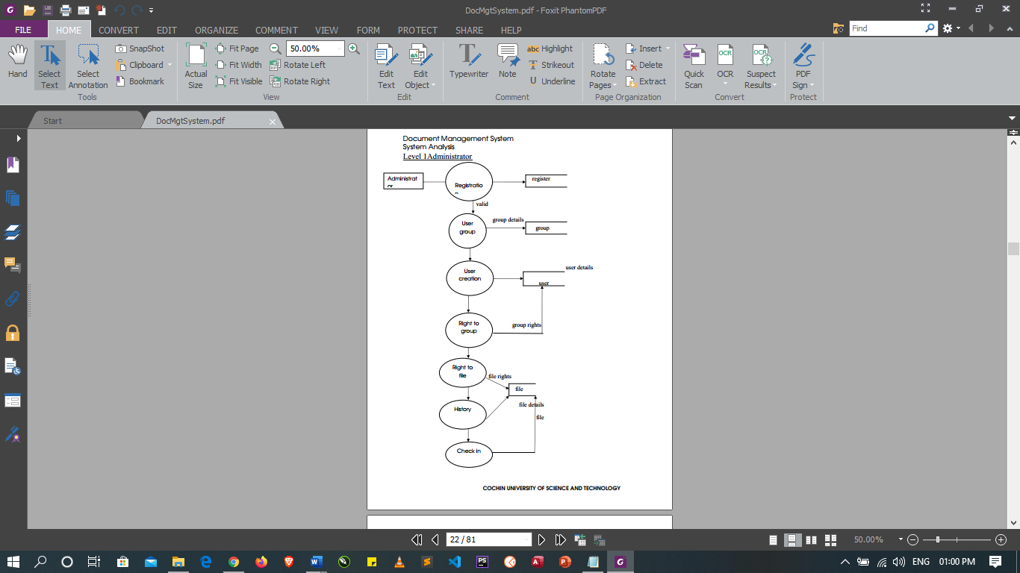

Figure 1 System Context Diagram 1

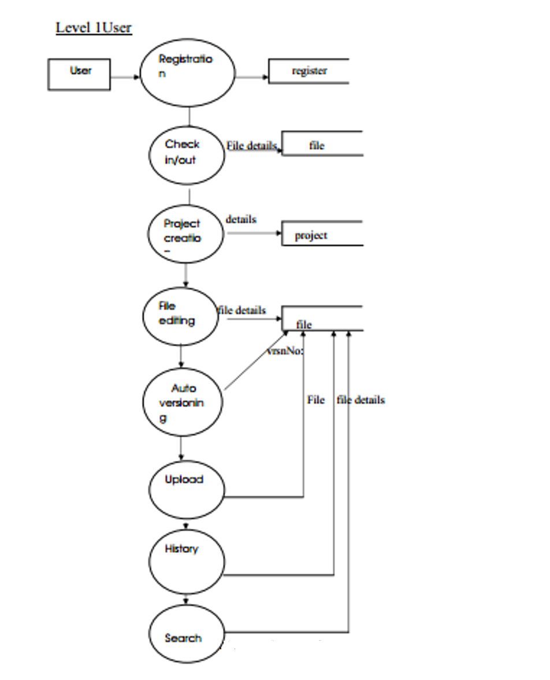

Figure 2 System Context Diagram

# Chapter 5

## 5. Detailed Design of the Proposed System

Software engineering is a carry out of using preferred procedure techniques to progress the quality of a software development effort. A methodology is defined as a collection of procedures, techniques, tools, and documentation aids which will help developers in their efforts (both product and process related activities) to implement a new system. For a successful design, a well-organized and systematic approach is crucial. Therefore, several methodologies were developed to encourage the systematic approach to planning, analysis, design, testing and implementation. Methodologies offer various tools and techniques to assist in analysis, design and testing in terms of detailed design of software, data flowcharts and database design

## 5.0 Functional Processes of the Proposed System

The functional processes of GAF DMS define the objective of the system.

1. User log in
2. Review Documents accessible
3. Create and edit documents
4. Create and edit users
5. Create access control on each data and prevent others from accessing.

## Algorithms or flowchart of the System

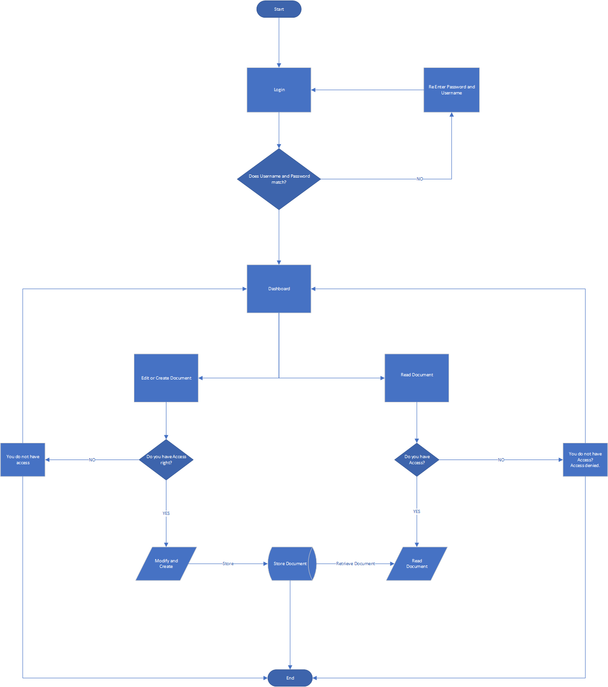

## Process Models

## Decision Tree

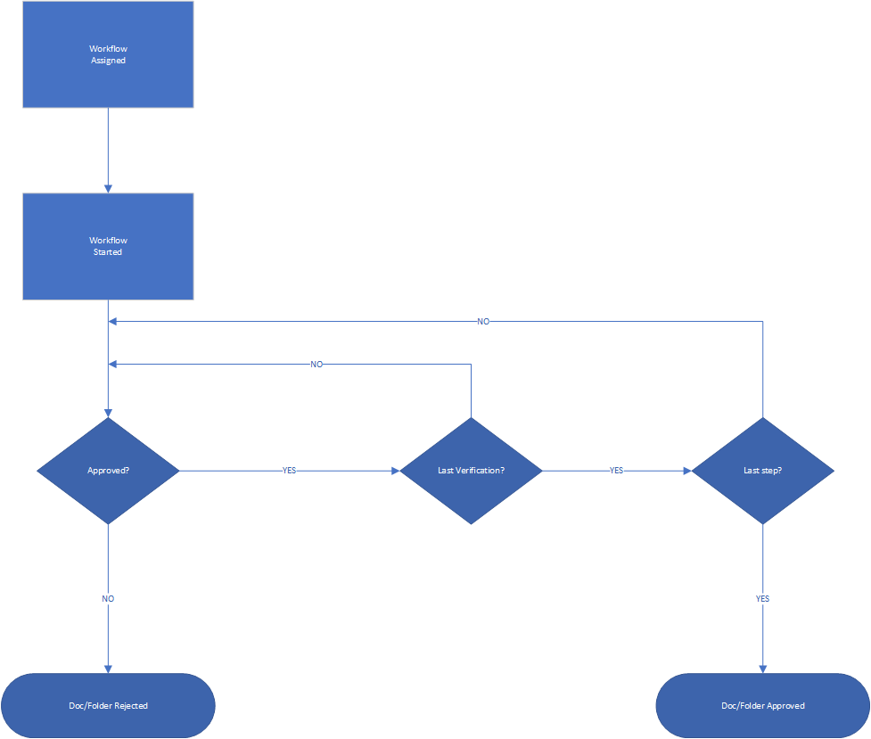

## UML Class Diagrams and Sequence

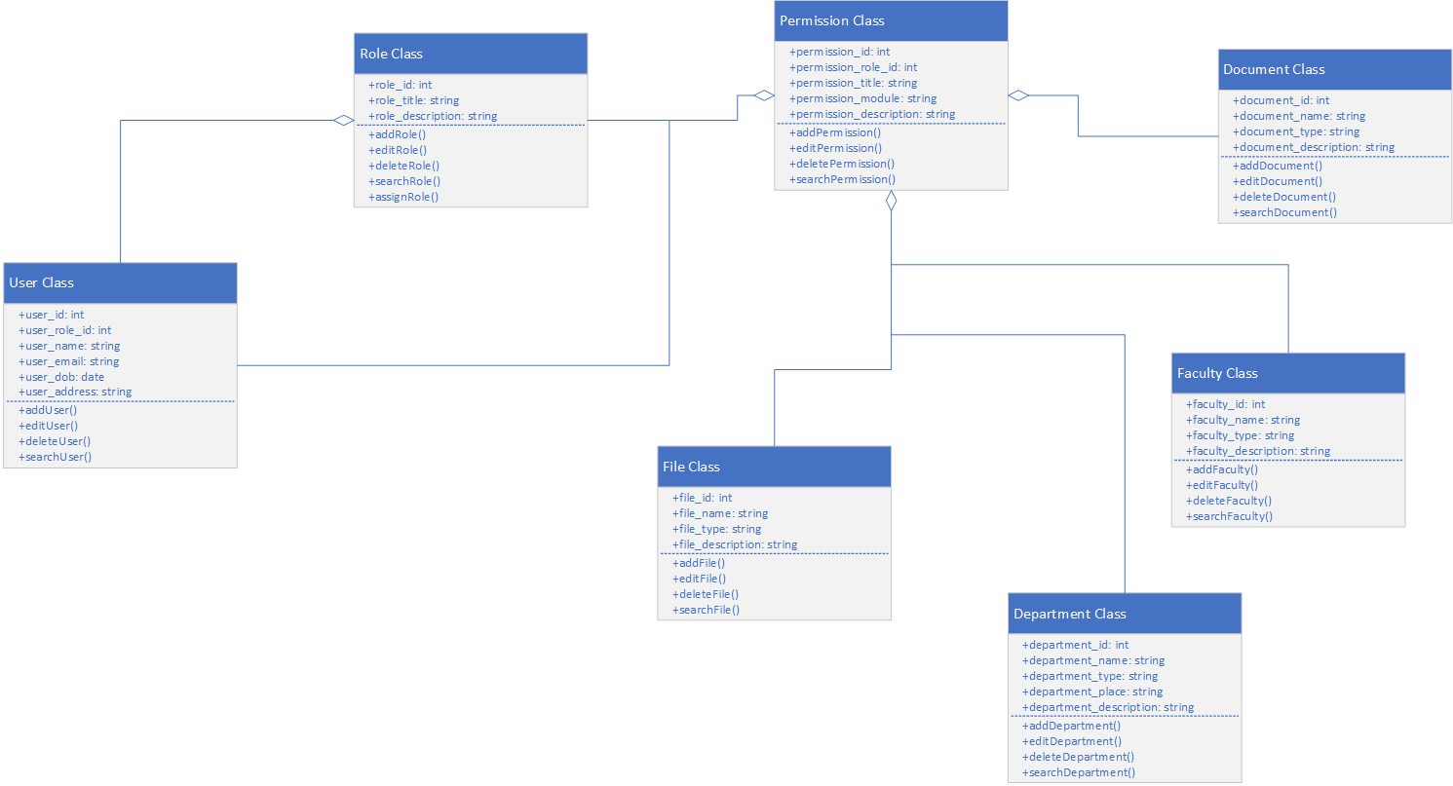

## Use Cases or User Scenarios or Activity Diagram

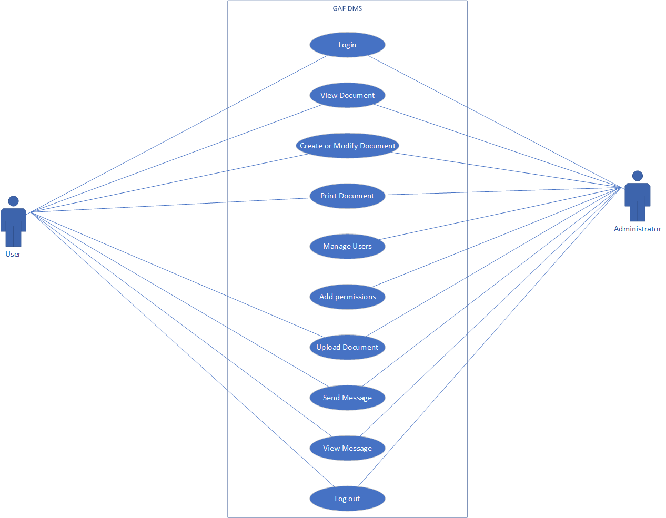

## Data Models

A data model is an abstract model that organizes elements of data and standardizes how they relate to one another and to the properties of the real-world entities.

Database schema is the structure of the database that defines the objects in the database. A schema is a collection of logical structures of data, or schema objects. A schema is owned by a database user and has the same name as that user. Each user owns a single schema. Schema objects can be created and manipulated with SQL and include the following types of objects:

a. Clusters

b. Database links

c. Database triggers

d. Dimensions

e. External procedure libraries

f. Indexes and index types

g. Materialized views and materialized view logs

h. Object tables, object types, and object views

i. Operators

j. Sequences

k. Stored functions, procedures, and packages

l. Synonyms

m. Tables and index-organized tables

n. Views

Other types of objects are also stored in the database and can be created and manipulated with SQL

but are not contained in a schema:

a. Contexts

b. Directories

c. Profiles

d. Roles

e. Tables paces

f. Users

g. Rollback segments

There are four levels of database schema thus:

a. Conceptual schema: Is a map of concepts and their relationships. This describes the semantics of an organization and represents a series of assertions about its nature. Specifically, it describes the things of significance to an organization (entity classes), about which it is inclined to collect information, and characteristics of (attributes) and associations between pairs of those things of significance (relationships).

b. Logical schema: Is a map of entities and their attributes and relations. The logical schema was the way data were represented to conform to the constraints of a particular approach to database management. Logical Schema is a data model of a specific problem domain expressed in terms of a particular data management technology.

c. Physical schema: Is a particular implementation of a logical schema. It describes how physically data would be stored on disk drives.

d. Schema object: is an MYSQL database object. Schema objects are logical data storage structures. Schema objects do not have a one-to-one correspondence to physical files on disk that store their information. However, MYSQL stores a schema object logically within a table space of the database. The data of each object is physically contained in one or more of the table space’s data files. For some objects, such as tables, indexes, and clusters, you can specify how much disk space MYSQL allocates for the object within the table space’s data files. There is no relationship between schemas and table spaces: a table space can contain objects from different schemas, and the objects for a schema can be contained in different table spaces.

## Data Dictionary

-Database Schema

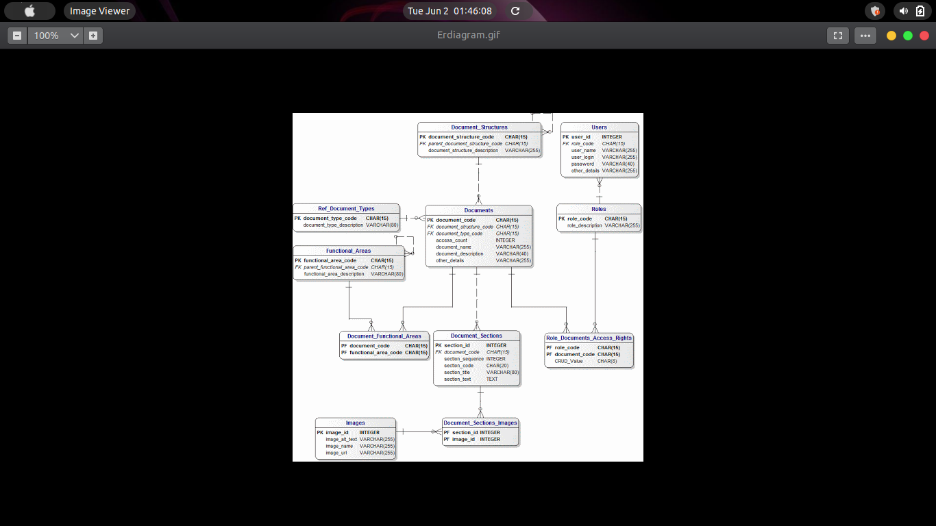

# Chapter 6

## Implementation of System design and Testing

Implementation is the realization of a technical specification or algorithm as a program or software component. It involves the accurate transform at or of the software design into some executable program code using any programming language of choice. A design may be implemented in various ways depending on the priorities of the software developer. In this work, several factors were taken into consideration during implementation. These factors include:

a. Correctness: The implementation was carried out with the aim of the final product meeting the user’s need.

b. Robustness: Robustness is the quality of being able to withstand stresses, pressures or changes in procedure or circumstance. Robustness was emphasized extensively in the implementation of this work. Defensive programming techniques were applied. Strict checking procedures were included to eliminate the possibility of unacceptable effects on system response.

c. Performance: Software performance is the extent to which a product meets its constraints with regard to response or space requirements. Performance optimization especially as regards speed / response time and appropriate search techniques were employed to ensure good response time.

## 6.0 Implementation/the Creation of the Software/Methods used in the project construction.

## 6.1 Programming or coding

PHP Hypertext Preprocessor (PHP) was chosen as the programming language which serves as the client to enable me to create the input and output forms while the MYSQL database was used as the database server.

Laravel is a framework (programming) for development of enterprise application using object-oriented programming.

Apart from mere suitability of the programming languages, many factors influenced the use of PHP as the programming language for the source code shown in the APPENDIX and the MYSQL database.

The Factors That Influenced the Choice of the PHP

a. Speed: Being a compiled language, it is very fast and speed is important in database application.

b. Environment: It can run in windows, MacOS, Linux. It is cross platform.

c. Efficient: The final code tends to be compact and run quickly.

d. Portability: If compiled, it can be executed in different machines with alteration of source code.

e. Maintainability: To ensure maintainability, this program is broken into modules and each module assigned a specific function. This will make maintenance of the system easier.

f. Security: it has proper backups, quality control mechanism for all modules and unauthorized access to sensitive data is prohibited.

Why MySQL Database Was Chosen:

a. Leading open source RDBMS

b. Ease of use – No frills

c. Fast and free

d. Robust

e. Security

f. Multiple OS support

g. Technical support

h. Support large database– up to 50 million rows, file size limit up to 8 Million TB.

## Detailed semantics of the operations of the software

Home page (welcome Screen)

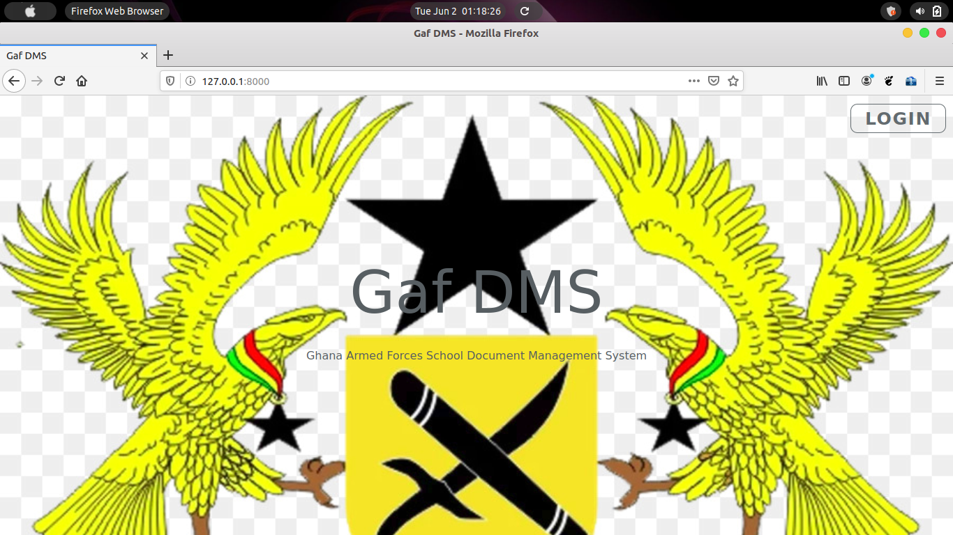

Code for home page

<!DOCTYPE html>

<html lang="{{ str_replace('_', '-', app()->getLocale()) }}">

<head>

<meta charset="utf-8">

<meta name="viewport" content="width=device-width, initial-scale=1">

<title>{{config('settings.system_title')}}</title>

<!-- Fonts -->

<link href="https://fonts.googleapis.com/css?family=Nunito:200,600" rel="stylesheet">

<!-- Styles -->

<style>

html, body {

background-color: #fff;

color: #575e62;

font-family: 'Nunito', sans-serif;

font-weight: 200;

height: 100vh;

margin: 0;

background-image: url("/assets/images/ghana.png");

background-repeat: no-repeat;

background-size: cover;

}

.full-height {

height: 100vh;

}

.flex-center {

align-items: center;

display: flex;

justify-content: center;

}

.position-ref {

position: relative;

}

.top-right {

position: absolute;

right: 10px;

top: 18px;

}

.content {

text-align: center;

}

.title {

font-size: 84px;

}

.links > a {

color: #636b6f;

padding: 5px 20px;

font-size: 25px;

font-weight: 600;

letter-spacing: .1rem;

text-decoration: none;

text-transform: uppercase;

border: 1px solid #636b6f;

border-radius: 10px;

}

.m-b-md {

margin-bottom: 30px;

}

</style>

</head>

<body>

<div class="flex-center position-ref full-height">

@if (Route::has('login'))

<div class="top-right links">

@auth

<a href="{{ route('admin.dashboard') }}">Home</a>

@else

<a href="{{ route('login') }}">Login</a>

@endauth

</div>

@endif

<div class="content">

<div class="title m-b-md">

{{config('settings.system_title')}}

</div>

<div class="links">

<blockquote>

{{-- {{$quotes}}--}}

Ghana Armed Forces School Document Management System

</blockquote>

</div>

</div>

</div>

</body>

</html>

Dashboard

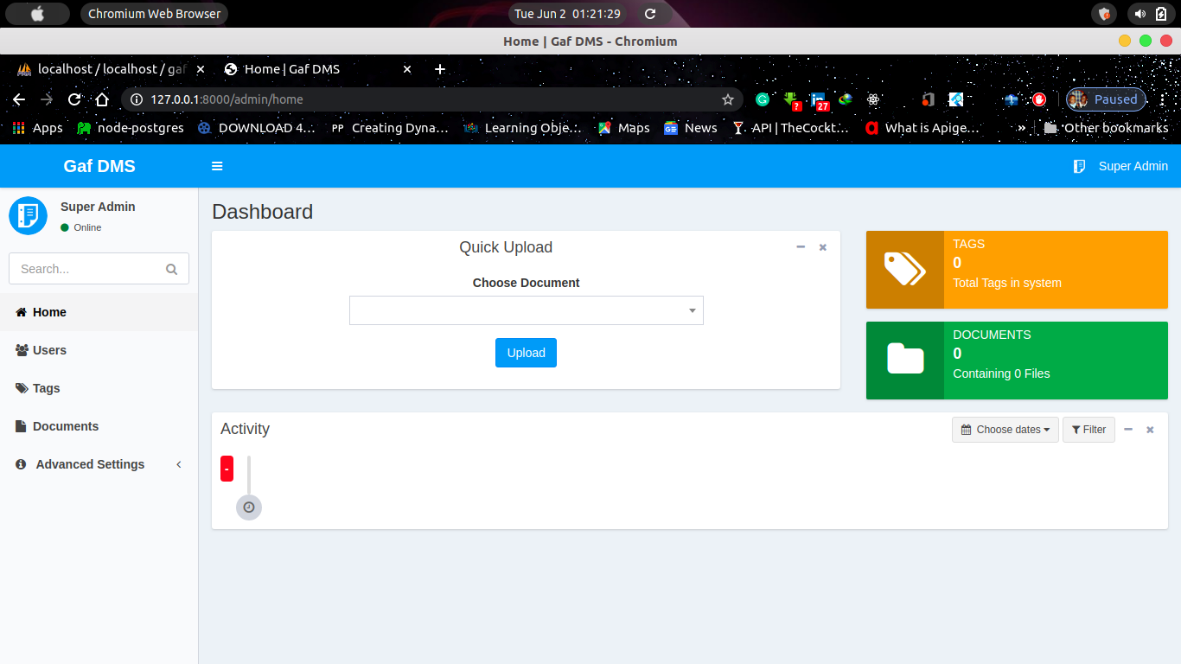

Code for Dashboard

@extends('layouts.app')

@section('title','Home')

@section('scripts')

<script>

function gotoUpload() {

var docId = $("#document_id").val();

var urlToUp = '{{route('documents.files.create',['id'=>''])}}'+'/'+docId;

console.log(urlToUp);

window.location.href = urlToUp;

return false;

}

$(function () {

$('#activityrange').daterangepicker(

{

ranges : {

'Today' : [moment(), moment()],

'Yesterday' : [moment().subtract(1, 'days'), moment().subtract(1, 'days')],

'Last 7 Days' : [moment().subtract(6, 'days'), moment()],

'Last 30 Days': [moment().subtract(29, 'days'), moment()],

'This Month' : [moment().startOf('month'), moment().endOf('month')],

'Last Month' : [moment().subtract(1, 'month').startOf('month'), moment().subtract(1, 'month').endOf('month')]

},

startDate: moment().subtract(29, 'days'),

endDate : moment()

},

function (start, end) {

$('#activityrange span').html(start.format('MMMM D, YYYY') + ' - ' + end.format('MMMM D, YYYY'));

$('#activity_range').val(start.format('YYYY-MM-DD') + 'to' + end.format('YYYY-MM-DD'));

}

);

@if(request()->has('activity_range'))

var dates = '{{request('activity_range')}}'.split('to');

var start = moment(dates[0]);

var end = moment(dates[1]);

$('#activityrange span').html(start.format('MMMM D, YYYY') + ' - ' + end.format('MMMM D, YYYY'));

@endif

});

</script>

@stop

@section('content')

<section class="content-header">

<h1 class="pull-left">Dashboard</h1>

</section>

<section class="content" style="margin-top: 20px;">

<div class="clearfix"></div>

<div class="clearfix"></div>

<div class="row">

<div class="col-md-8">

<div class="box box-default">

<div class="box-header no-border text-center">

<h3 class="box-title">Quick Upload</h3>

<div class="box-tools pull-right">

<button type="button" class="btn btn-box-tool" data-widget="collapse"><i

class="fa fa-minus"></i>

</button>

<button type="button" class="btn btn-box-tool" data-widget="remove"><i

class="fa fa-times"></i></button>

</div>

</div>

<div class="box-body">

<form action="#" class="text-center" style="width: 30vw;margin: 0 auto;" onsubmit="return gotoUpload()">

<div class="form-group">

<label for="">Choose {{ucfirst(config('settings.document_label_singular'))}}</label>

<select name="document_id" id="document_id" class="form-control select2">

@foreach ($documents as $document)

@can('view',$document)

<option value="{{$document->id}}">{{$document->name}}</option>

@endcan

@endforeach

</select>

</div>

<div class="form-group">

<button class="btn btn-primary">Upload</button>

</div>

</form>

</div>

</div>

</div>

<div class="col-md-4">

<div class="info-box bg-yellow">

<span class="info-box-icon"><i class="fa fa-tags"></i></span>

<div class="info-box-content">

<span class="info-box-text">{{ucfirst(config('settings.tags_label_plural'))}}</span>

<span class="info-box-number">{{$tagCounts}}</span>

<span class="progress-description">

Total {{ucfirst(config('settings.tags_label_plural'))}} in system

</span>

</div>

<!-- /.info-box-content -->

</div>

<div class="info-box bg-green">

<span class="info-box-icon"><i class="fa fa-folder"></i></span>

<div class="info-box-content">

<span class="info-box-text">{{ucfirst(config('settings.document_label_plural'))}}</span>

<span class="info-box-number">{{$documentCounts}}</span>

<span class="progress-description">

Containing {{$filesCounts}} {{ucfirst(config('settings.file_label_plural'))}}

</span>

</div>

<!-- /.info-box-content -->

</div>

</div>

</div>

<div class="row">

<div class="col-sm-12">

<div class="box box-default">

<div class="box-header no-border">

<h3 class="box-title">Activity</h3>

<div class="box-tools pull-right">

{!! Form::open(['method' => 'get','style'=>'display:inline;']) !!}

{!! Form::hidden('activity_range', '', ['id' => 'activity_range']) !!}

<button type="button" id="activityrange" class="btn btn-default btn-sm">

<i class="fa fa-calendar"></i>&nbsp;

<span>Choose dates</span> <i class="fa fa-caret-down"></i>

</button>

{!! Form::button('<i class="fa fa-filter"></i>&nbsp;Filter', ['class' => 'btn btn-default btn-sm','type'=>'submit']) !!}

{!! Form::close() !!}

<button type="button" class="btn btn-box-tool" data-widget="collapse"><i

class="fa fa-minus"></i>

</button>

<button type="button" class="btn btn-box-tool" data-widget="remove"><i

class="fa fa-times"></i></button>

</div>

</div>

<div class="box-body">

<ul class="timeline">

<li class="time-label">

<span class="bg-red">{{formatDate(optional($activities->first())->created_at,'d M Y')}}</span>

</li>

@foreach ($activities as $activity)

@can('view',$activity->document)

<li>

<i class="fa fa-user bg-aqua" data-toggle="tooltip"

title="{{$activity->createdBy->name}}"></i>

<div class="timeline-item">

<span class="time" data-toggle="tooltip"

title="{{formatDateTime($activity->created_at)}}"><i

class="fa fa-clock-o"></i> {{\Carbon\Carbon::parse($activity->created_at)->diffForHumans()}}</span>

<h4 class="timeline-header no-border">{!! $activity->activity !!}</h4>

</div>

</li>

@endcan

@endforeach

<li>

<i class="fa fa-clock-o bg-gray"></i>

</li>

</ul>

<div class="text-center">

{!! $activities->appends(request()->all())->render() !!}

</div>

</div>

</div>

</div>

</div>

</section>

@endsection

Create Document

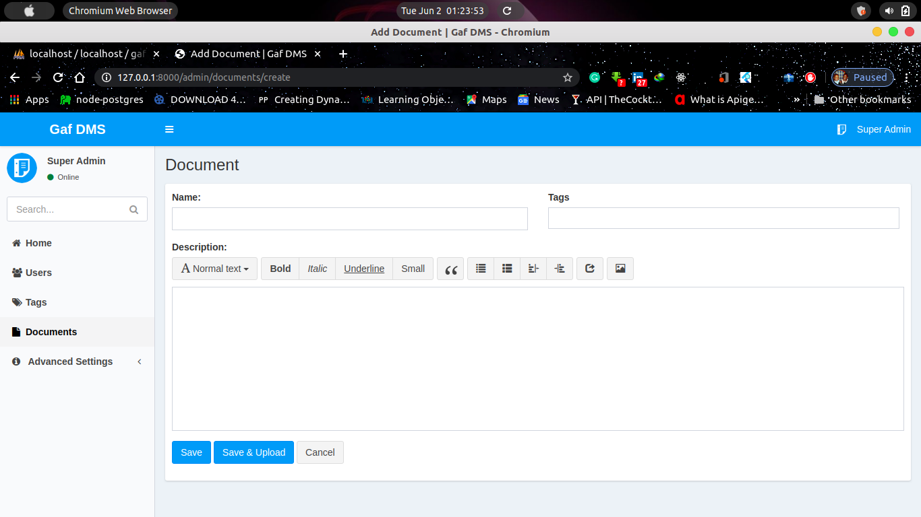

Code for Create Document

@extends('layouts.app')

@section('title',ucfirst(config('settings.document_label_plural'))." List")

@section('css')

<style type="text/css">

.bg-folder-shaper {

width: 100%;

height: 115px;

border-radius: 0px 15px 15px 15px !Important;

}

.folder-shape-top {

width: 57px;

height: 17px;

border-radius: 20px 37px 0px 0px;

position: absolute;

top: -16px;

left: 0;

right: 0;

bottom: 0;

}

.widget-user-2 .widget-user-username, .widget-user-2 .widget-user-desc {

margin-left: 10px;

font-weight: 400;

font-size: 17px;

}

.widget-user-username {

white-space: nowrap;

overflow: hidden;

text-overflow: ellipsis;

}

.m-t-20 {

margin-top: 20px;

}

.dropdown-menu {

min-width: 100%;

}

.doc-box.box {

box-shadow: 0 0px 0px rgba(0, 0, 0, 0.0) !important;

}

.bg-folder-shaper:hover {

background-color: yellow;

}

.select2-container {

width: 100% !important;

}

#filterForm.in, filterForm.collapsing {

display: block !important;

}

</style>

@stop

@section('scripts')

<script>

</script>

@stop

@section('content')

<section class="content-header">

<h1 class="pull-left">

{{ucfirst(config('settings.document_label_plural'))}}

</h1>

<h1 class="pull-right">

@can('create',\App\Document::class)

<a href="{{route('documents.create')}}"

class="btn btn-primary">

<i class="fa fa-plus"></i>

Add New

</a>

@endcan

</h1>

</section>

<div class="content" style="margin-top: 22px;">

<div class="clearfix"></div>

@include('flash::message')

<div class="clearfix"></div>

<div class="box box-primary">

<div class="box-header">

<div class="form-group hidden visible-xs">

<button type="button" class="btn btn-default btn-block" data-toggle="collapse"

data-target="#filterForm"><i class="fa fa-filter"></i> Filter

</button>

</div>

{!! Form::model(request()->all(), ['method'=>'get','class'=>'form-inline visible hidden-xs','id'=>'filterForm']) !!}

<div class="form-group">

<label for="search" class="sr-only">Search</label>

{!! Form::text('search',null,['class'=>'form-control input-sm','placeholder'=>'Search...']) !!}

</div>

<div class="form-group">

<label for="tags" class="sr-only">{{config('settings.tags_label_singular')}}:</label>

<select class="form-control select2 input-sm" name="tags[]" id="tags"

data-placeholder="Choose {{config('settings.tags_label_singular')}}" multiple>

@foreach($tags as $tag)

@canany(['read documents','read documents in tag '.$tag->id])

<option

value="{{$tag->id}}" {{in_array($tag->id,request('tags',[]))?'selected':''}}>{{$tag->name}}</option>

@endcanany

@endforeach

</select>

</div>

<div class="form-group">

<label for="status" class="sr-only">{{config('settings.tags_label_singular')}}:</label>

{!! Form::select('status',['0'=>"ALL",config('constants.STATUS.PENDING')=>config('constants.STATUS.PENDING'),config('constants.STATUS.APPROVED')=>config('constants.STATUS.APPROVED'),config('constants.STATUS.REJECT')=>config('constants.STATUS.REJECT')],null,['class'=>'form-control input-sm']) !!}

</div>

<button type="submit" class="btn btn-default btn-sm"><i class="fa fa-filter"></i> Filter</button>

{!! Form::close() !!}

</div>

<div class="box-body">

<div class="row">

@foreach ($documents as $document)

@cannot('view',$document)

@continue

@endcannot

<div class="col-lg-2 col-md-2 col-sm-4 col-xs-6 m-t-20" style="cursor:pointer;">

<div class="doc-box box box-widget widget-user-2">

<div class="widget-user-header bg-gray bg-folder-shaper no-padding">

<div class="folder-shape-top bg-gray"></div>

<div class="box-header">

<a href="{{route('documents.show',$document->id)}}" style="color: black;">

<h3 class="box-title"><i class="fa fa-folder text-yellow"></i></h3>

</a>

<div class="box-tools pull-right">

<div class="btn-group">

<button type="button" class="btn btn-default btn-flat dropdown-toggle"

data-toggle="dropdown" aria-expanded="false"

style=" background: transparent;border: none;">

<i class="fa fa-ellipsis-v"></i>

<span class="sr-only">Toggle Dropdown</span>

</button>

<ul class="dropdown-menu dropdown-menu-left" role="menu">

<li><a href="{{route('documents.show',$document->id)}}">Show</a>

</li>

@can('edit',$document)

<li><a href="{{route('documents.edit',$document->id)}}">Edit</a>

</li>

@endcan

@can('delete',$document)

<li>

{!! Form::open(['route' => ['documents.destroy', $document->id], 'method' => 'delete']) !!}

{!! Form::button('Delete', [

'type' => 'submit',

'class' => 'btn btn-link',

'onclick' => "return conformDel(this,event)"

]) !!}

{!! Form::close() !!}

</li>

@endcan

</ul>

</div>

</div>

</div>

<!-- /.widget-user-image -->

<a href="{{route('documents.show',$document->id)}}" style="color: black;">

<span style="max-lines: 1; white-space: nowrap;margin-left: 3px;">

@foreach ($document->tags as $tag)

<small class="label"

style="background-color: {{$tag->color}};font-size: 0.93rem;">{{$tag->name}}</small>

@endforeach

</span>

<h5 class="widget-user-username" title="{{$document->name}}"

data-toggle="tooltip">{{$document->name}}</h5>

<h5 class="widget-user-desc" style="font-size: 12px"><span data-toggle="tooltip"

title="{{formatDateTime($document->updated_at)}}">{{formatDate($document->updated_at)}}</span>

<span

class="pull-right" style="margin-right: 15px;">

{!! $document->isVerified ? '<i title="Verified" data-toggle="tooltip" class="fa fa-check-circle" style="color: #388E3C;"></i>':'<i title="Unverified" data-toggle="tooltip" class="fa fa-remove" style="color: #f44336;"></i>' !!}

</span></h5>

</a>

</div>

</div>

<!-- /.widget-user -->

</div>

@endforeach

</div>

</div>

<div class="box-footer">

{!! $documents->appends(request()->all())->render() !!}

</div>

</div>

</div>

@endsection

Login

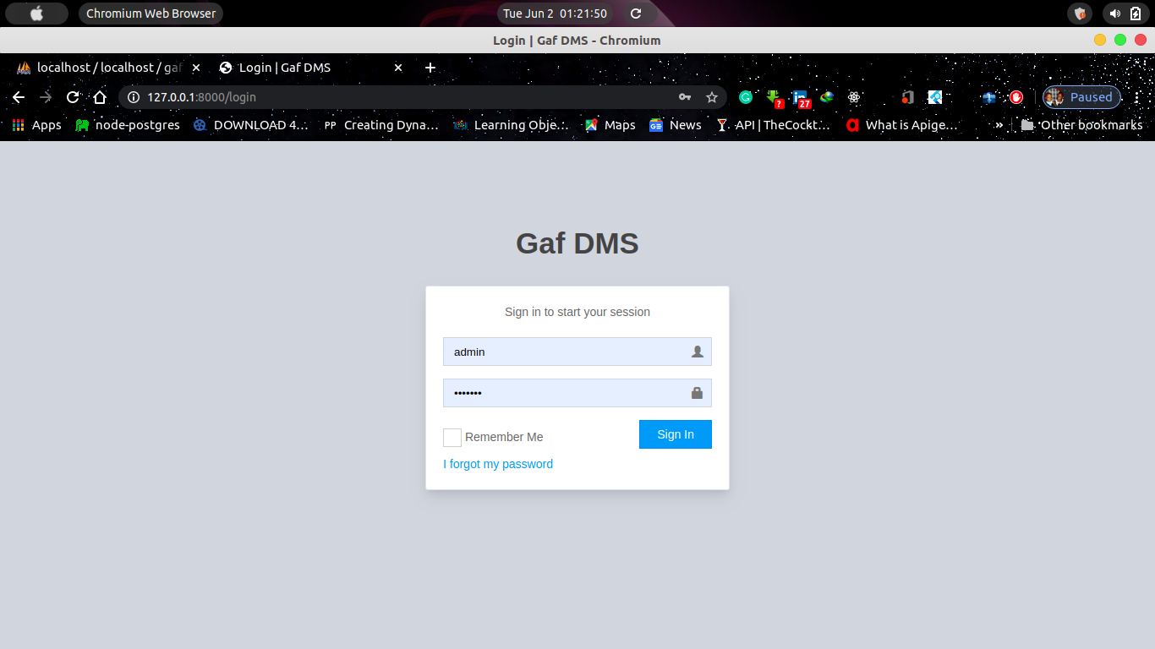

Code for login

<!DOCTYPE html>

<html lang="en">

<head>

<meta charset="utf-8">

<meta http-equiv="X-UA-Compatible" content="IE=edge">

<title>Login | {{config('settings.system_title')}}</title>

<!-- Tell the browser to be responsive to screen width -->

<meta content="width=device-width, initial-scale=1, maximum-scale=1, user-scalable=no" name="viewport">

<!-- Bootstrap 3.3.7 -->

<link rel="stylesheet" href="https://maxcdn.bootstrapcdn.com/bootstrap/3.3.7/css/bootstrap.min.css">

<!-- Font Awesome -->

<link rel="stylesheet" href="https://cdnjs.cloudflare.com/ajax/libs/font-awesome/4.7.0/css/font-awesome.min.css">

<!-- Theme style -->

<link rel="stylesheet" href="{{asset('css/lte/AdminLTE.min.css')}}">

<link rel="stylesheet" href="{{asset('css/lte/skins/skin-blue-light.min.css')}}">

<!-- iCheck -->

<link rel="stylesheet" href="https://cdnjs.cloudflare.com/ajax/libs/iCheck/1.0.2/skins/square/_all.css">

<!-- HTML5 Shim and Respond.js IE8 support of HTML5 elements and media queries -->

<!-- WARNING: Respond.js doesn't work if you view the page via file:// -->

<!--[if lt IE 9]>

<script src="https://oss.maxcdn.com/html5shiv/3.7.3/html5shiv.min.js"></script>

<script src="https://oss.maxcdn.com/respond/1.4.2/respond.min.js"></script>

<![endif]-->

<style>

.login-box-body{

border: 1px solid rgba(0, 40, 100, 0.12) !important;

box-shadow: 0 10px 15px -3px rgba(0,0,0,.1),0 4px 6px -2px rgba(0,0,0,.05) !important;

border-radius: 3px;

}

</style>

</head>

<body class="hold-transition login-page">

<div class="login-box">

<div class="login-logo">

<a href="{{ route('home') }}"><b>{{config('settings.system_title')}} </b></a>

</div>

<!-- /.login-logo -->

<div class="login-box-body">

<p class="login-box-msg">Sign in to start your session</p>

<form method="post" action="{{ url('/login') }}">

{!! csrf_field() !!}

<div class="form-group has-feedback {{ $errors->has('username') ? ' has-error' : '' }}">

<input type="text" class="form-control" name="username" value="{{ old('username') }}" placeholder="Username">

<span class="glyphicon glyphicon-user form-control-feedback"></span>

@if ($errors->has('username'))

<span class="help-block">

<strong>{{ $errors->first('username') }}</strong>

</span>

@endif

</div>

<div class="form-group has-feedback{{ $errors->has('password') ? ' has-error' : '' }}">

<input type="password" class="form-control" placeholder="Password" name="password">

<span class="glyphicon glyphicon-lock form-control-feedback"></span>

@if ($errors->has('password'))

<span class="help-block">

<strong>{{ $errors->first('password') }}</strong>

</span>

@endif

</div>

<div class="row">

<div class="col-xs-8">

<div class="checkbox icheck">

<label>

<input type="checkbox" name="remember"> Remember Me

</label>

</div>

</div>

<!-- /.col -->

<div class="col-xs-4">

<button type="submit" class="btn btn-primary btn-block btn-flat">Sign In</button>

</div>

<!-- /.col -->

</div>

</form>

<a href="{{ url('/password/reset') }}">I forgot my password</a><br>

{{--<a href="{{ url('/register') }}" class="text-center">Register a new membership</a>--}}

</div>

<!-- /.login-box-body -->

</div>

<!-- /.login-box -->

<script src="https://ajax.googleapis.com/ajax/libs/jquery/3.2.1/jquery.min.js"></script>

<script src="https://maxcdn.bootstrapcdn.com/bootstrap/3.3.7/js/bootstrap.min.js"></script>

<!-- AdminLTE App -->

<script src="https://cdnjs.cloudflare.com/ajax/libs/admin-lte/2.4.3/js/adminlte.min.js"></script>

<script src="https://cdnjs.cloudflare.com/ajax/libs/iCheck/1.0.2/icheck.min.js"></script>

<script>

$(function () {

$('input').iCheck({

checkboxClass: 'icheckbox_square-blue',

radioClass: 'iradio_square-blue',

increaseArea: '20%' // optional

});

});

</script>

</body>

</html>

Profile module

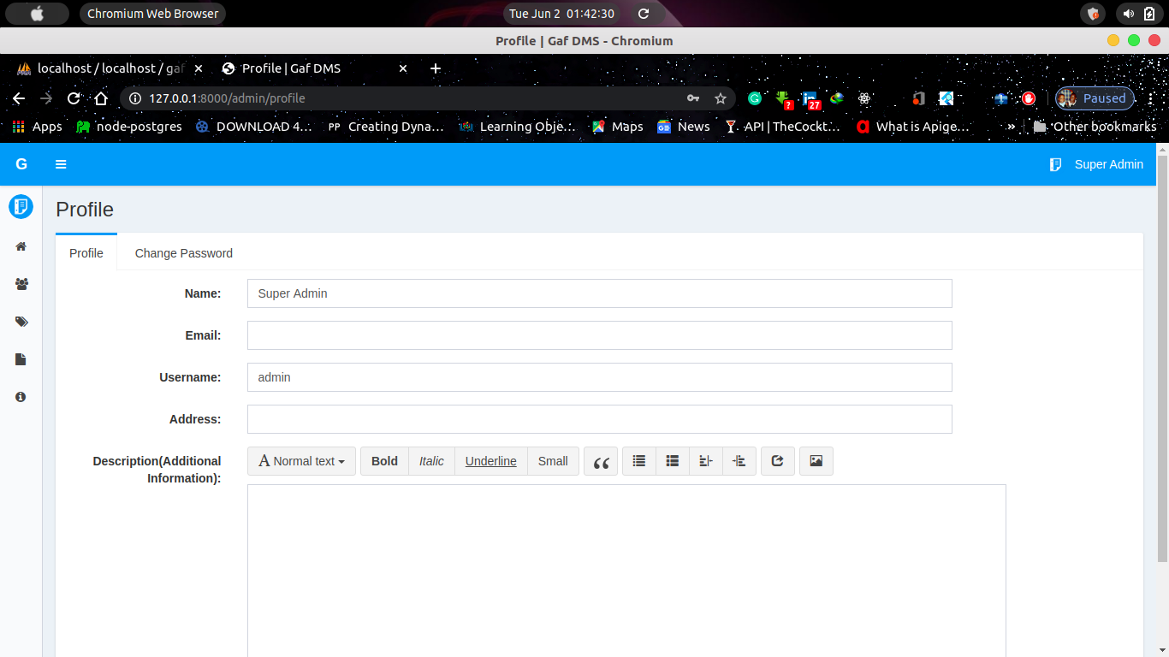

Code for profile Module

@extends('layouts.app')

@section('title','Profile')

@section('scripts')

<script>

$(function () {

var url = document.location.toString();

if (url.match('#')) {

$('.nav-tabs a[href="#' + url.split('#')[1] + '"]').tab('show');

}

$('.nav-tabs a').on('shown.bs.tab', function (e) {

window.location.hash = e.target.hash;

});

});

</script>

@stop

@section('content')

<section class="content-header" style="margin-bottom: 25px;">

<h1 class="pull-left">

Profile

</h1>

</section>

<div class="content">

<div class="clearfix"></div>

@include('flash::message')

<div class="clearfix"></div>

<div class="row">

<div class="col-sm-12">

<div class="nav-tabs-custom">

<ul class="nav nav-tabs">

<li class="active"><a href="#profile" data-toggle="tab" aria-expanded="true">Profile</a></li>

<li class=""><a href="#ch_pwd" data-toggle="tab" aria-expanded="false">Change Password</a></li>

</ul>

<div class="tab-content">

<div class="tab-pane active" id="profile">

{!! Form::model($profile,['class'=>'form-horizontal']) !!}

<div class="form-group {{$errors->has('name')?'has-error':''}}">

{!! Form::label('name', 'Name:', ['class' => 'control-label col-sm-2']) !!}

<div class="col-sm-8">

{!! Form::text('name', null, ['class' => 'form-control']) !!}

{!! $errors->first("name",'<span class="help-block">:message</span>') !!}

</div>

</div>

<div class="form-group {{$errors->has('email')?'has-error':''}}">

{!! Form::label('email', 'Email:', ['class' => 'control-label col-sm-2']) !!}

<div class="col-sm-8">

{!! Form::email('email', null, ['class' => 'form-control']) !!}

{!! $errors->first("email",'<span class="help-block">:message</span>') !!}

</div>

</div>

<div class="form-group {{$errors->has('username')?'has-error':''}}">

{!! Form::label('username', 'Username:', ['class' => 'control-label col-sm-2']) !!}

<div class="col-sm-8">

{!! Form::text('username', null, ['class' => 'form-control']) !!}

{!! $errors->first("username",'<span class="help-block">:message</span>') !!}

</div>

</div>

<div class="form-group {{$errors->has('address')?'has-error':''}}">

{!! Form::label('address', 'Address:', ['class' => 'control-label col-sm-2']) !!}

<div class="col-sm-8">

{!! Form::text('address', null, ['class' => 'form-control']) !!}

{!! $errors->first("address",'<span class="help-block">:message</span>') !!}

</div>

</div>

<div class="form-group {{$errors->has('description')?'has-error':''}}">

{!! Form::label('description', 'Description(Additional Information):', ['class' => 'control-label col-sm-2']) !!}

<div class="col-sm-10">

{!! Form::textarea('description', null, ['class' => 'form-control b-wysihtml5-editor']) !!}

{!! $errors->first("description",'<span class="help-block">:message</span>') !!}

</div>

</div>

<div class="form-group">

<div class="col-sm-offset-2 col-sm-8">

<button type="submit" class="btn btn-primary" value="btnprofile" name="btnprofile">

Update Profile

</button>

</div>

</div>

{!! Form::close() !!}

</div>

<div class="tab-pane" id="ch_pwd">

{!! Form::model($profile,['class'=>'form-horizontal']) !!}

<div class="form-group {{$errors->has('old_password')?'has-error':''}}">

{!! Form::label('old_password', 'Old Password:', ['class' => 'control-label col-sm-2']) !!}

<div class="col-sm-8">

{!! Form::password('old_password', ['class' => 'form-control']) !!}

{!! $errors->first("old_password",'<span class="help-block">:message</span>') !!}

</div>

</div>

<div class="form-group {{$errors->has('new_password')?'has-error':''}}">

{!! Form::label('new_password', 'New Password:', ['class' => 'control-label col-sm-2']) !!}

<div class="col-sm-8">

{!! Form::password('new_password', ['class' => 'form-control']) !!}

{!! $errors->first("new_password",'<span class="help-block">:message</span>') !!}

</div>

</div>

<div class="form-group">

<div class="col-sm-offset-2 col-sm-8">

<button type="submit" class="btn btn-primary" value="btnpass" name="btnpass">

Change Password

</button>

</div>

</div>

{!! Form::close() !!}

</div>

</div>

</div>

</div>

</div>

</div>

@endsection

## The purpose of the implementation

## 6.4 Testing - Description of the testing strategy

The purpose of testing is to discover errors. Testing is the process of trying to discover every conceivable fault or weakness in a work product. It provides a way to check the functionality of components, sub-assemblies, assemblies and/or a finished product. It is the process of exercising software with the intent of ensuring that the Software system meets its requirements and user expectations and does not fail in an unacceptable manner. There are various types of test. Each test type addresses a specific testing requirement.

**TYPES OF TESTING**

* **Unit testing**: Unit testing involves the design of test cases that validate that the internal program logic is functioning properly, and that program inputs produce valid outputs. All decision branches and internal code flow should be validated. It is the testing of individual software units of the application. It is done after the completion of an individual unit before integration. This is a structural testing, that relies on knowledge of its construction and is invasive. Unit tests perform basic tests at component level and test a specific business process, application, and/or system configuration. Unit tests ensure that each unique path of a business process performs accurately to the documented specifications and contains clearly defined inputs and expected results.
* **Integration testing**: Integration tests are designed to test integrated software components to determine if they actually run as one program. Testing is event driven and is more concerned with the basic outcome of screens or fields. Integration tests demonstrate that although the components were individually satisfaction, as shown by successfully unit testing, the combination of components is correct and consistent. Integration testing is specifically aimed at exposing the problems that arise from the combination of components.
* **Functional test**: Functional tests provide systematic demonstrations that functions tested are available as specified by the business and technical requirements, system documentation, and user manuals. Functional testing is centered on the following items:

a. Valid Input: identified classes of valid input must be accepted.

b. Invalid Input: identified classes of invalid input must be rejected.

c. Functions: identified functions must be exercised.

d. Output: identified classes of application outputs must be exercised.

e. Systems/Procedures: interfacing systems or procedures must be invoked.

Organization and preparation of functional tests is focused on requirements, key functions, or special test cases. In addition, systematic coverage pertaining to identify Business process flows; data fields, predefined processes, and successive processes must be considered for testing. Before functional testing is complete, additional tests are identified and the effective value of current tests is determined.

* **System Test**: System testing ensures that the entire integrated software system meets requirements. It tests a configuration to ensure known and predictable results. An example of system testing is the configuration-oriented system integration test. System testing is based on process descriptions and flows, emphasizing pre-driven process links and integration points.
* **White Box Testing**: White Box Testing is a testing in which the software tester has knowledge of the inner workings, structure and language of the software, or at least its purpose. It is purpose. It is used to test areas that cannot be reached from a black box level.
* **Black Box Testing** is testing the software without any knowledge of the inner workings, structure or language of the module being tested. Black box tests, as most other kinds of tests, must be written from a definitive source document, such as specification or requirements, such as specification or requirements document. It is a testing in which the software under test is treated, as a black box. You cannot “see” into it. The test provides inputs and responds to outputs without considering how the software works.
* **Test strategy and approach**

Field testing will be performed manually and functional tests will be written in detail

1. **Test objectives**

a. All field entries must work properly.

b. Pages must be activated from the identified link.

c. The entry screen, messages and responses must not be delayed.

1. **Features to be tested**

a. Verify that the entries are of the correct format

b. No duplicate entries should be allowed

c. All links should take the user to the correct page.

**Test Results**: All the test cases mentioned above passed successfully. No defects encountered

# Chapter 7

## System Documentation

## - User Manual for the system

ADMIN PANEL

DASHBOARD

Total users, documents, departments, document history and settings at a glance.

MANAGE DEPARTMENTS

* Manage all departments of the institution

* Create a new department

* Edit any department

* Delete a department

— How to create a new department?

Click on add department button from department page of admin panel, fill out the form and click

on submit button.

MANAGE USERS

* Manage all users of the institution

* Create a new user

* Edit any user

* Delete a user

— How to create a new user?

Click on add user button from users page of admin panel, fill out the form and click on submit

button.

MANAGE DOCUMENTS

* Manage all documents of the documents

* Create a new document

* Edit any document

* Delete a document

— How to create a new document?

Click on add document button from document page of admin panel, fill out the form and click on submit

button.

PROFILE

Edit profile and password of the admin

USERS PANEL

DASHBOARD

Total documents, departments, document history and settings at a glance.

MANAGE DEPARTMENTS

* Manage all departments of the institution

* Create a new department

* Edit any department

* Delete a department

— How to create a new department?

Click on add department button from department page of admin panel, fill out the form and click

on submit button.

MANAGE DOCUMENTS

* Manage all documents of the documents

* Create a new document

* Edit any document

* Delete a document

— How to create a new document?

Click on add document button from document page of admin panel, fill out the form and click on submit

button.

PROFILE

Edit profile and password of the admin

## - Description of both the Hardware and Software required

**Software used**

**Tools Used:**

* Laravel (PHP framework),
* Notepad++

**Technologies:**

* PHP,
* HTML,
* JavaScript,
* CSS

TOOLS USED

Laravel

* Laravel is an Application Framework

Laravel is a toolkit for people who build web applications using PHP. Its goal is to enable you to develop projects much faster than you could if you were writing code from scratch, by providing a rich set of libraries for commonly needed tasks, as well as a simple interface and logical structure to access these libraries. Laravel lets you creatively focus on your project by minimizing the amount of code needed for a given task.

* Laravel is Free

Laravel is licensed under the MIT license so you can use it however you please. For more information please read the [license agreement](https://laravel.com).

* Laravel is Light Weight

Truly light weight. The core system requires only a few very small libraries. This is in stark contrast to many frameworks that require significantly more resources. Additional libraries are loaded dynamically upon request, based on your needs for a given process, so the base system is very lean and quite fast.

* Laravel Uses M-V-C

Laravel uses the Model-View-Controller approach, which allows great separation between logic and presentation. This is particularly good for projects in which designers are working with your template files, as the code these files contain will be minimized. We describe MVC in more detail on its own page.

* Laravel Generates Clean URLs

The URLs generated by Laravel are clean and search-engine friendly. Rather than using the standard “query string” approach to URLs that is synonymous with dynamic systems, Laravel uses a segment-based approach: example.com/news/article/345

Note

By default, the index.php file is included in the URL but it can be removed using a simple .htaccess file.

* Laravel Packs a Punch

Laravel comes with full-range of libraries that enable the most commonly needed web development tasks, like accessing a database, sending email, validating form data, maintaining sessions, manipulating images, working with XML-RPC data and much more.

* Laravel is Extensible

The system can be easily extended through the use of your own libraries, helpers, or through class extensions or system hooks.

* Laravel is Thoroughly Documented

Programmers love to code and hate to write documentation. We’re no different, of course, but since documentation is as important as the code itself, we are committed to doing it. Our source code is extremely clean and well commented as well.

* Laravel has a Friendly Community of Users

Our growing community of users can be seen actively participating in our Community Forums.

* Laravel Features

Features in and of themselves are a very poor way to judge an application since they tell you nothing about the user experience, or how intuitively or intelligently it is designed. Features don’t reveal anything about the quality of the code, or the performance, or the attention to detail, or security practices. The only way to really judge an app is to try it and get to know the code. Installing Laravel is child’s play so we encourage you to do just that. In the mean time here’s a list of Laravel ’s main features.

a. Model-View-Controller Based System

b. Extremely Light Weight

c. Full Featured database classes with support for several platforms.

d. Query Builder Database Support

e. Form and Data Validation

f. Security and XSS Filtering

g. Session Management

h. Email Sending Class. Supports Attachments, HTML/Text email, multiple protocols (sendmail, SMTP, and Mail) and more.

i. Image Manipulation Library (cropping, resizing, rotating, etc.). Supports GD, ImageMagick, and NetPBM

j. File Uploading Class and FTP Class

k. Localization

l. Pagination and Data Encryption

m. Benchmarking

n. Full Page Caching

o. Error Logging

p. Application Profiling

q. Calendaring Class

r. User Agent Class

s. Zip Encoding Class

t. Template Engine Class and Trackback Class

u. XML-RPC Library

v. Unit Testing Class

w. Search-engine Friendly URLs

x. Flexible URI Routing

y. Support for Hooks and Class Extensions

z. Large library of “helper” functions

* Application Flow Chart

The following graphic illustrates how data flows throughout the system:

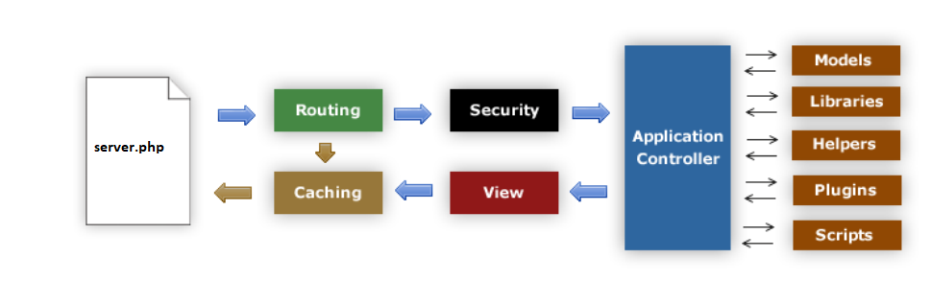

a. The server.php serves as the front controller, initializing the base resources needed to run Laravel.

b. The Router examines the HTTP request to determine what should be done with it.

c. If a cache file exists, it is sent directly to the browser, bypassing the normal system execution.

d. Security. Before the application controller is loaded, the HTTP request and any user submitted data is filtered for security.

e. The Controller loads the model, core libraries, helpers, and any other resources needed to process the specific request.

f. The finalized View is rendered then sent to the web browser to be seen. If caching is enabled, the view is cached first so that on subsequent requests it can be served.

* Model-View-Controller

Laravel is based on the Model-View-Controller development pattern. MVC is a software approach that separates application logic from presentation. In practice, it permits your web pages to contain minimal scripting since the presentation is separate from the PHP scripting.

a. The Model represents your data structures. Typically, your model classes will contain functions that help you retrieve, insert, and update information in your database.

b. The View is the information that is being presented to a user. A View will normally be a web page, but in Laravel, a view can also be a page fragment like a header or footer. It can also be an RSS page, or any other type of “page”.

c. The Controller serves as an intermediary between the Model, the View, and any other resources needed to process the HTTP request and generate a web page. Laravel has a fairly loose approach to MVC since Models are not required. If you don’t need the added separation, or find that maintaining models requires more complexity than you want, you can ignore them and build your application minimally using Controllers and Views. Laravel also enables you to incorporate your own existing scripts, or even develop core libraries for the system, enabling you to work in a way that makes the most sense to you.

* Design and Architectural Goals

The goal for Laravel is maximum performance, capability, and flexibility in the smallest, lightest possible package.

From a technical and architectural standpoint, Laravel was created with the following

objectives:

a. Dynamic Instantiation. In Laravel, components are loaded and routines executed only when requested, rather than globally. No assumptions are made by the system regarding what may be needed beyond the minimal core resources, so the system is very light-weight by default. The events, as triggered by the HTTP request, and the controllers and views you design will determine what is invoked.

b. Loose Coupling. Coupling is the degree to which components of a system rely on each other. The less components depend on each other the more reusable and flexible the system becomes. Our goal was a very loosely coupled system.

c. Component Singularity. Singularity is the degree to which components have a narrowly focused purpose. In Laravel, each class and its functions are highly autonomous in order to allow maximum usefulness. Laravel is a dynamically instantiated, loosely coupled system with high component singularity. It strives for simplicity, flexibility, and high performance in a small footprint package.

* SERVER REQUIREMENTS

PHP version 7.2 or newer is recommended.

It should work on 7.0 as well, but we strongly advise you NOT to run such old versions of PHP, because of potential security and performance issues, as well as missing features.

A database is required for most web application programming. Currently supported databases are:

a. MySQL (5.1+) via the mysql(deprecated), mysqli and pdo drivers

b. MYSQL via the oci8 and pdo drivers

c. PostgreSQL via the postgre and pdo drivers

d. MS SQL via the mssql, sqlsrv (version 2005 and above only) and pdo drivers

e. SQLite via the sqlite (version 2), sqlite3 (version 3) and pdo drivers

f. CUBRID via the cubrid and pdo drivers

g. Interbase/Firebird via the ibase and pdo drivers

h. ODBC via the odbc and pdo drivers (you should know that ODBC is actually an abstraction

layer)

**TECHNOLOGIES USED**

* HTML or Hypertext Markup Language is the standard markup language used to create web pages. HTML is written in the form of HTML elements consisting of tags enclosed in angle brackets (like <html>). HTML tags most commonly come in pairs like <h1> and </h1>, although some tags represent empty elements and so are unpaired, for example <img>. The first tag in a pair is the start tag, and the second tag is the end tag (they are also called opening tags and closing tags). Though not always necessary, it is best practice to append a slash to tags which are not paired with a closing tag.
* CASCADING STYLE SHEETS (CSS)

It is a style sheet language used for describing the look and formatting of a document written in a markup language. While most often used to style web pages and interfaces written in HTML and XHTML, the language can be applied to any kind ofXML document, including plain XML, SVG and XUL. CSS is a cornerstone specification of the web and almost all web pages use CSS style sheets to describe their presentation. CSS is designed primarily to enable the separation of document content from document presentation, including elements such as the layout, colors, and fonts. This separation can improve content accessibility, provide more flexibility and control in the specification of presentation characteristics, enable multiple pages to share formatting, and reduce complexity and repetition in the structural content.

* MySQL

MySQL is developed, distributed, and supported by MYSQL Corporation. MySQL is a database system used on the web it runs on a server. MySQL is ideal for both small and large applications. It is very fast, reliable, and easy to use. It supports standard SQL. MySQL can be compiled on a number of platforms. The data in MySQL is stored in tables. A table is a collection of related data, and it consists of columns and rows. Databases are useful when storing information categorically.

* FEATURES OF MySQL

Internals and portability:

a. Written in C and C++.

b. Tested with a broad range of different compilers.

c. Works on many different platforms.

d. Tested with Purify (a commercial memory leakage detector) as well as with Val grind, a GPL tool.

e. Uses multi-layered server design with independent modules.

* Security

a. A privilege and password system that is very flexible and secure, and that enables host-based verification.

b. Password security by encryption of all password traffic when you connect to a server.

* Scalability and Limits

a. Support for large databases. We use MySQL Server with databases that contain 50 million records. We also know of users who use MySQL Server with 200,000 tables and about 5,000,000,000 rows.

b. Support for up to 64 indexes per table (32 before MySQL 4.1.2). Each index may consist of 1 to 16 columns or parts of columns. The maximum index width is 767 bytes for InnoDB tables, or 1000 for MyISAM; before MySQL 4.1.2, the limit is 500 bytes. An index may use a prefix of a column for CHAR, VARCHAR, BLOB, or TEXT column types.

* Connectivity

Clients can connect to MySQL Server using several protocols:

a. Clients can connect using TCP/IP sockets on any platform.

b. On Windows systems in the NT family (NT, 2000, XP, 2003, or Vista), clients can connect using named pipes if the server is started with the --enable-named-pipe option. In MySQL 4.1 and higher, Windows servers also support shared-memory connections if started with the -- shared-memory option. Clients can connect through shared memory by using the -- protocol=memory option.

c. On UNIX systems, clients can connect using UNIX domain socket files.

* Localization:

a. The server can provide error messages to clients in many languages.

b. All data is saved in the chosen character set.

* CLIENTS AND TOOLS

a. MySQL includes several client and utility programs. These include both command-line programs such as mysqldump and mysqladmin, and graphical programs such as MySQL Workbench.

b. MySQL Server has built-in support for SQL statements to check, optimize, and repair tables. These statements are available from the command line through the mysqlcheck client. MySQL also includes myisamchk, a very fast command-line utility for performing these operations on MyISAM tables.

c. MySQL programs can be invoked with the --help or -? option to obtain online assistance.

* WHY TO USE MySQL

a. Leading open source RDBMS

b. Ease of use – No frills

c. Fast

d. Robust

e. Security

f. Multiple OS support

g. Free

h. Technical support

i. Support large database– up to 50 million rows, file size limit up to 8 Million TB

* JAVASCRIPT

JavaScript is the scripting language of the Web. All modern HTML pages are using JavaScript. A scripting language is a lightweight programming language. JavaScript code can be inserted into any HTML page, and it can be executed by all types of web browsers. JavaScript is easy to learn.

# Chapter 8

## Conclusion, Recommendation and Further Work

**CONCLUSION**

The main aim of this project is to deliver effective information and management services. It is a software-based application to deliver operational speed and service efficiency in any target Institution. The project Electronic Document Management System is very accurate in its approach and suits all environments including large, medium or small-scale schools. In evaluating the document management system, it is observed that the project is successful. It is designed and tested to provide the following benefit:

a. Document management system not only provides an opportunity to the training school to enhance their collaborations but also increases the profitability of the organization.

b. The training school will now require smaller number of paper documents since everything is now automated.

c. This software system allows for development of additional modules and service automations as the resources and job tasks of the institution grow in time.

d. Upgrading of the software does not and will not require taking down of the existing running application modules.

e. The training school administrators would be able to significantly improve the operational control and thus streamline operations.

f. Document Management System would enable the training school to improve the response time to the demands of documents and also prevent duplication and enable accurate tracing of documents.

**RECOMMENDATIONS**

Any future enhancements related to this project should be able to implement instant messaging and acknowledgement related to messaging module. Implement instant notifications across all modules as soon as a document is added to the system and a backup feature to perform system backup.

# C. References/Bibliography

Open KM, Document management, Open source document management system software, 2020, <https://www.openkm.com/en/document-management.html>

AIIM.Org, what is document management? Document Imaging, 2017, [https://www.aiim.org/What-Is-Document-Imaging#](https://www.aiim.org/What-Is-Document-Imaging)

Captera, Best Document management software 2020, What is document management software, 2020 <https://www.capterra.com/document-management-software/>

J. P. Sathiadas, [**Gihan Wikramanayake**](https://www.researchgate.net/profile/Gihan_Wikramanayake), publication, Document Management Techniques and Technologies, 2020, <https://www.researchgate.net/publication/216361358_Document_Management_Techniques_and_Technologies>

Susan Ward, The balancesmb, How to Create a Document Management System, 2020, <https://www.thebalancesmb.com/creating-a-document-management-system-2948084>

logicalDoc, solutions, Document Management System, 2020, <https://www.logicaldoc.com/solutions/document-management>